**Data Manipulation and Reporting with Power BI**

# Business Requirement

Zomato is a restaurant aggregation and meal delivery service based in India. It is currently operating in several countries across the world. Zomato provides thorough information about numerous eateries as well as consumer reviews. Zomato's owners aim to find hidden irregularities in their company's data.

The data (sample) is currently accessible in the form of a few Excel files, each of which contains information about multiple restaurants operating in a certain continent.

The clients want to construct a consolidated and interactive Power BI report that will allow them to do the following:

* Derive data on the total number of restaurants worldwide, including continents, countries, and cities.
* View data on a global scale with the capacity to drill down to a granular level.
* Derive data on the restaurants with the highest average customer ratings.
* Discover the restaurants with the lowest average costs.
* Filter and view information on the restaurants based on:
  + Their geographical dimensions such as continent, country, and city.
  + The service they provide, such as online ordering or reservation services.
  + The average rating slab by color.
* Identify the restaurants with the most cuisines served.
* Design a multi-page report that suits Zomato's theme with easy navigation across sections.
* Allow Zomato users to be able to access this information from both a web browser and a mobile device.

# Data Load

* Upload all data from all the available Excel Files one-by-one by navigating to ‘Home Tab’ > ‘Get Data’ and selecting ‘Excel Workbook’. ([Files for Project](https://github.com/Simplilearn-Edu/Power-BI-Datasets/blob/master/Files%20for%20project.zip)).

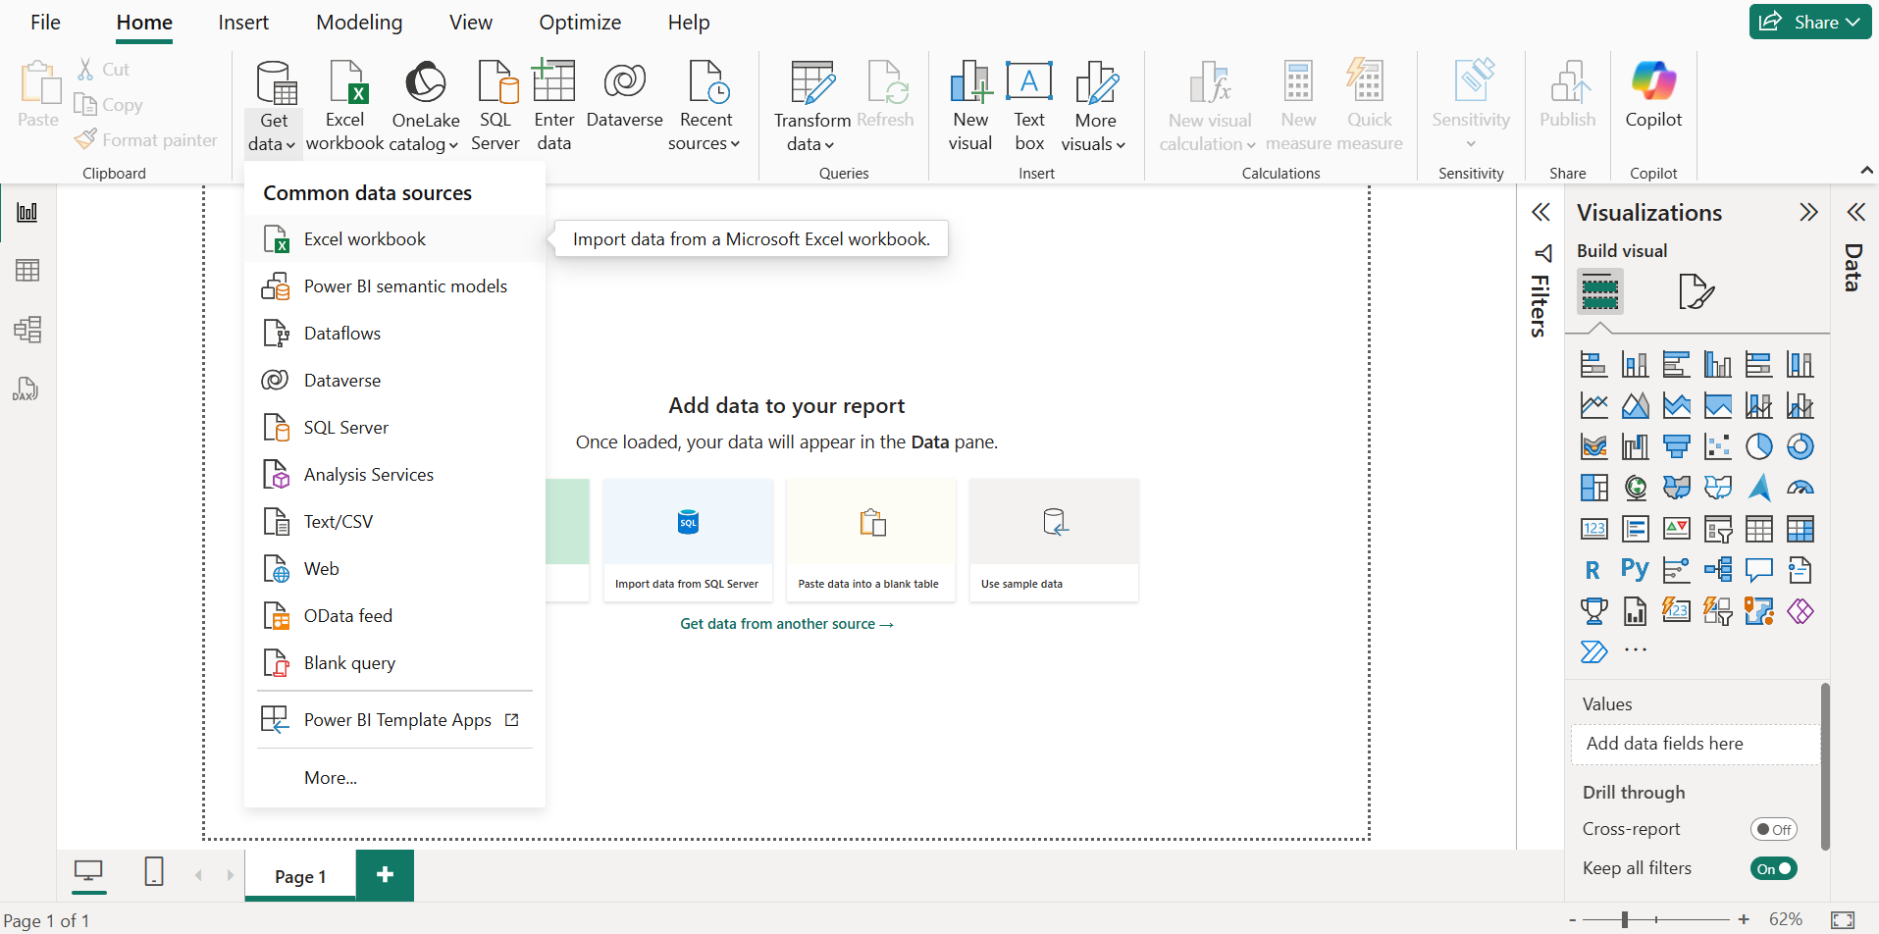

* Upon File selection, we need to ‘Load’ the data in Power BI

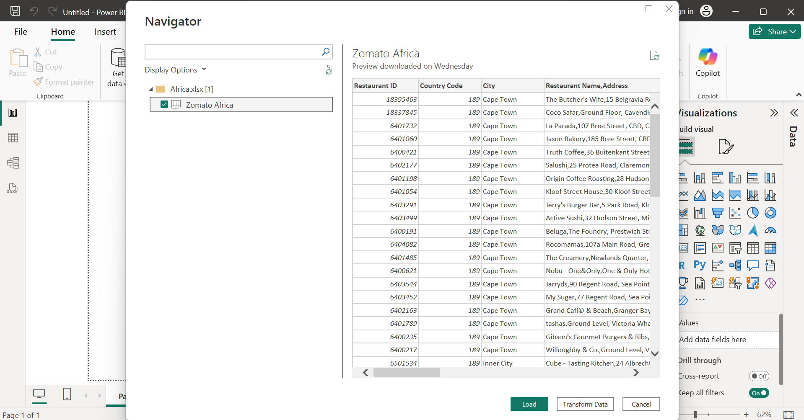

* Once all the data is loaded in Power BI it would be visible in the ‘Data Pane’.

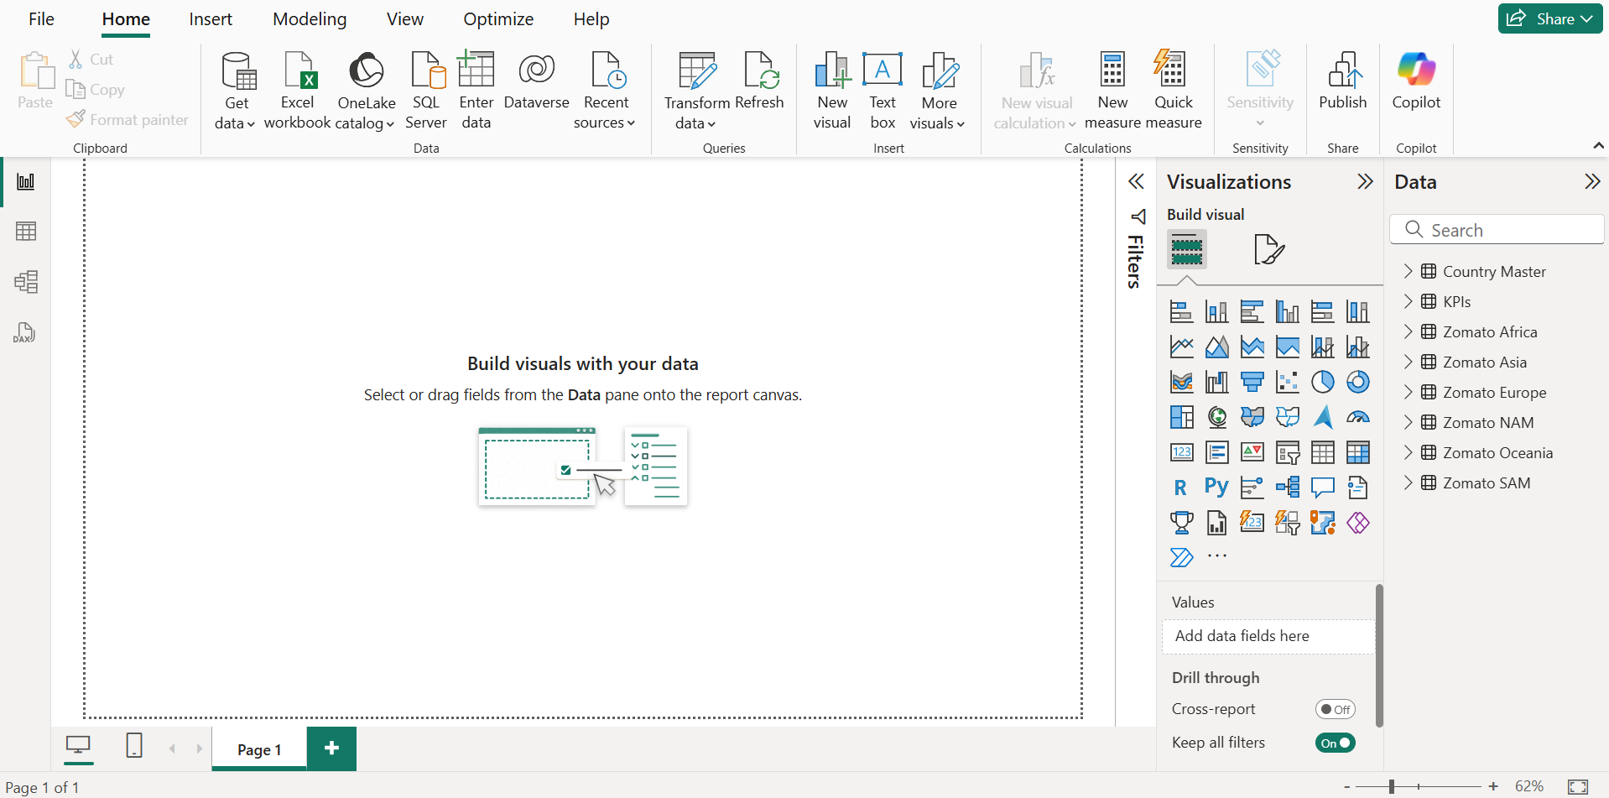

# Data Transformation

To perform Data Transformation, we need to navigate to the ‘Transform Data’ option under ‘Home Tab’.

## 3.1 Append Tables

To transform data from all Zomato regions first we would create a new table ‘Zomato Regions’ to save time required for transformation and avoid to many to many relationships in model.

* To create this Table we would use the ‘Append Queries’ function.

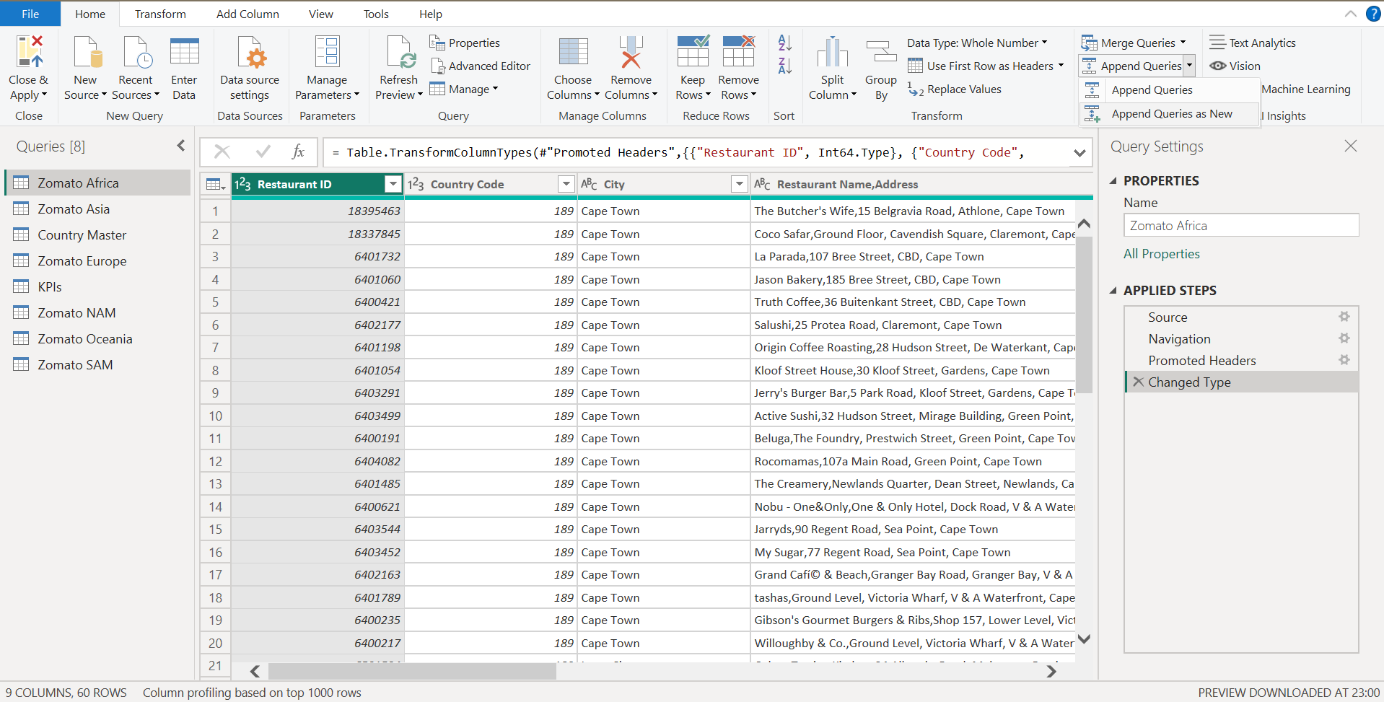

* Select the Tables we need to append and click on ‘Ok’, this would create a new table.

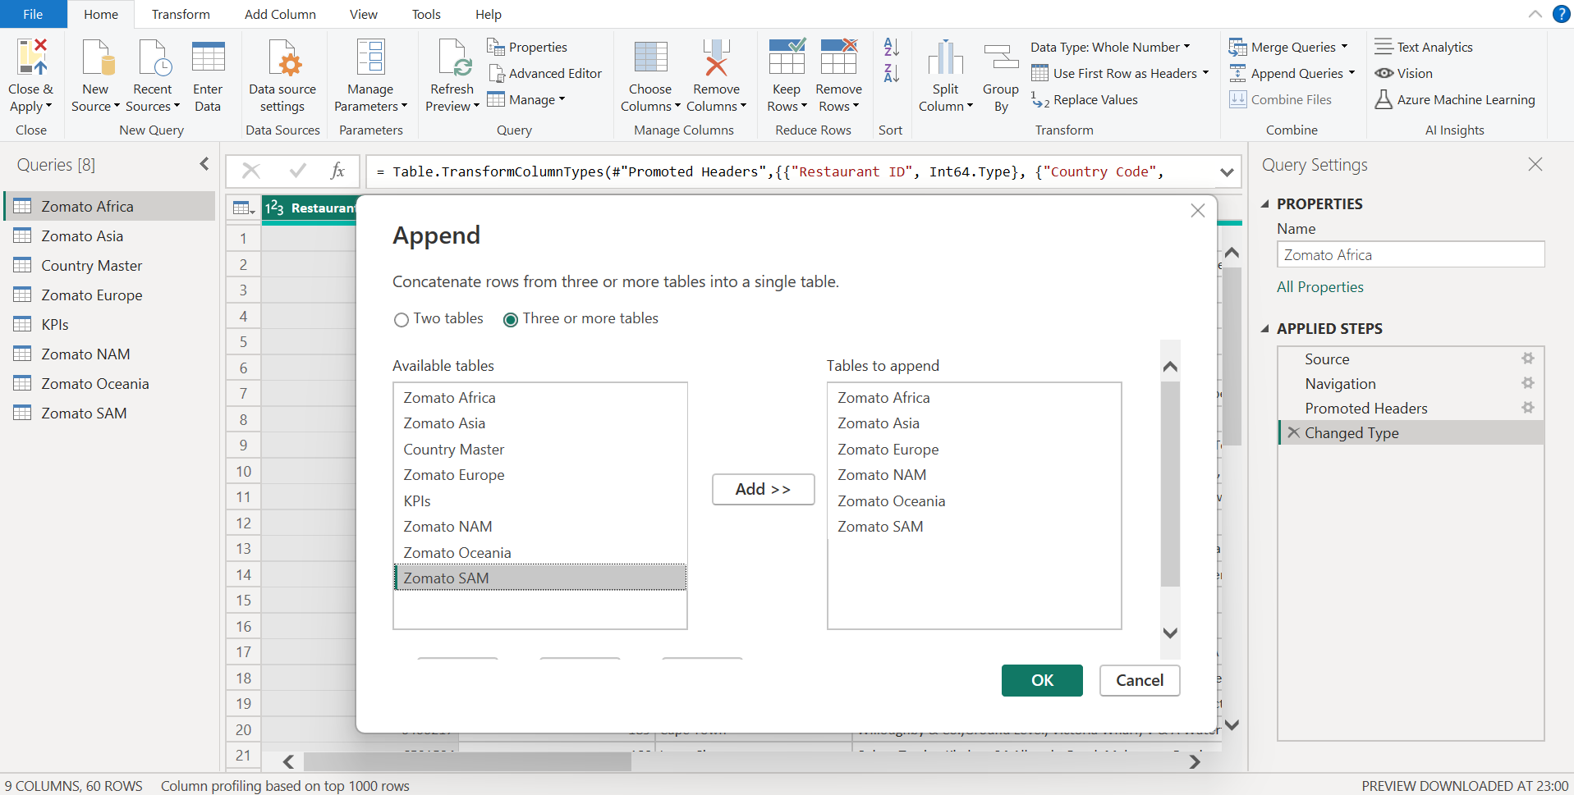

* Disable Load of the individual regions table.

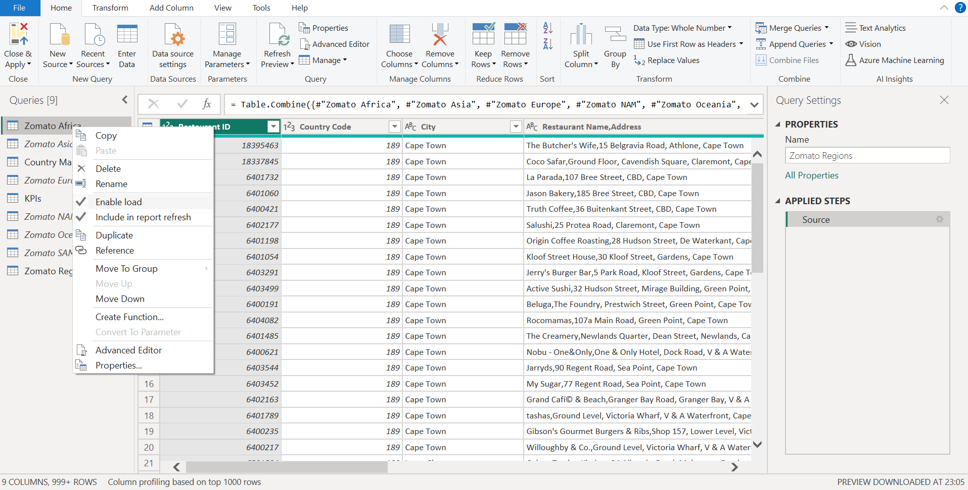

## 3.2 Table - Zomato Regions

We would clean the Data in ‘Zomato Regions’ by performing the below steps

* Split the ‘Restaurant Name,Address’ column by Delimiter to get two separate columns for Restaurant Name and Restaurant Address

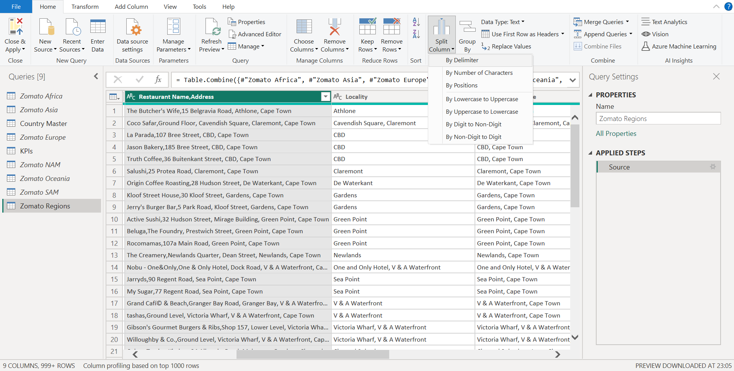

* Split the Column by ‘,’

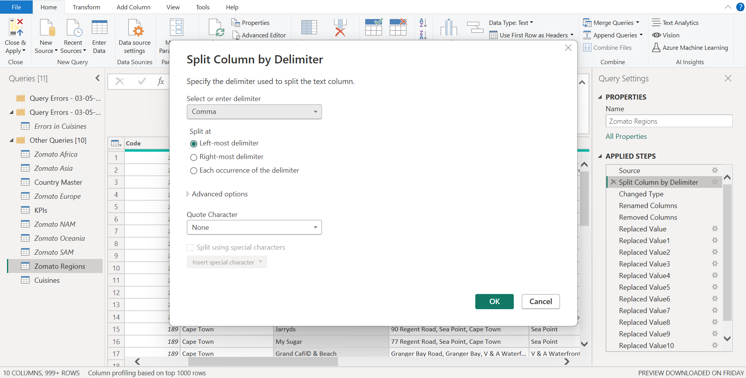

* Rename the New columns to ‘Restaurant Name’ and ‘Restaurant Address’ respectively.

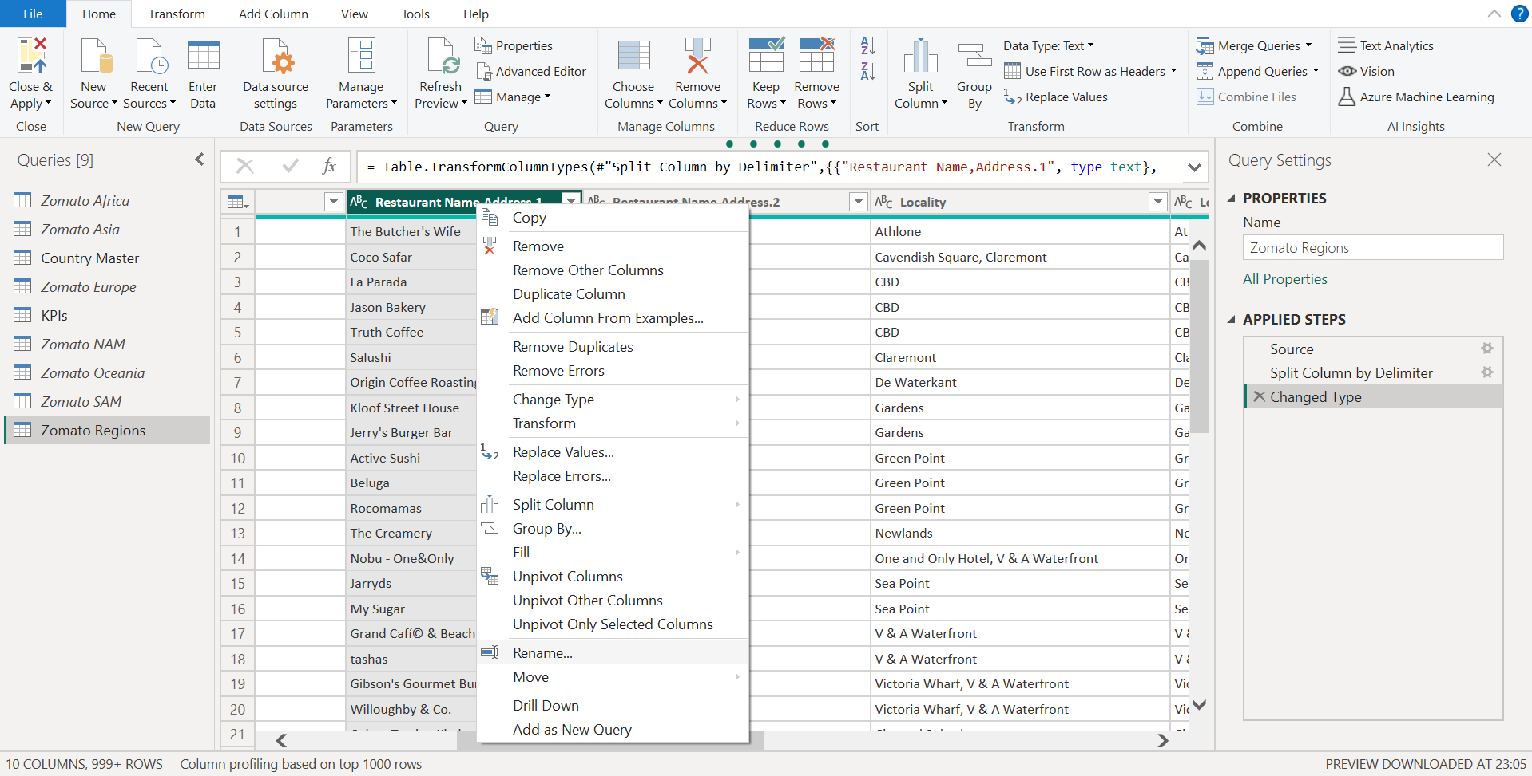

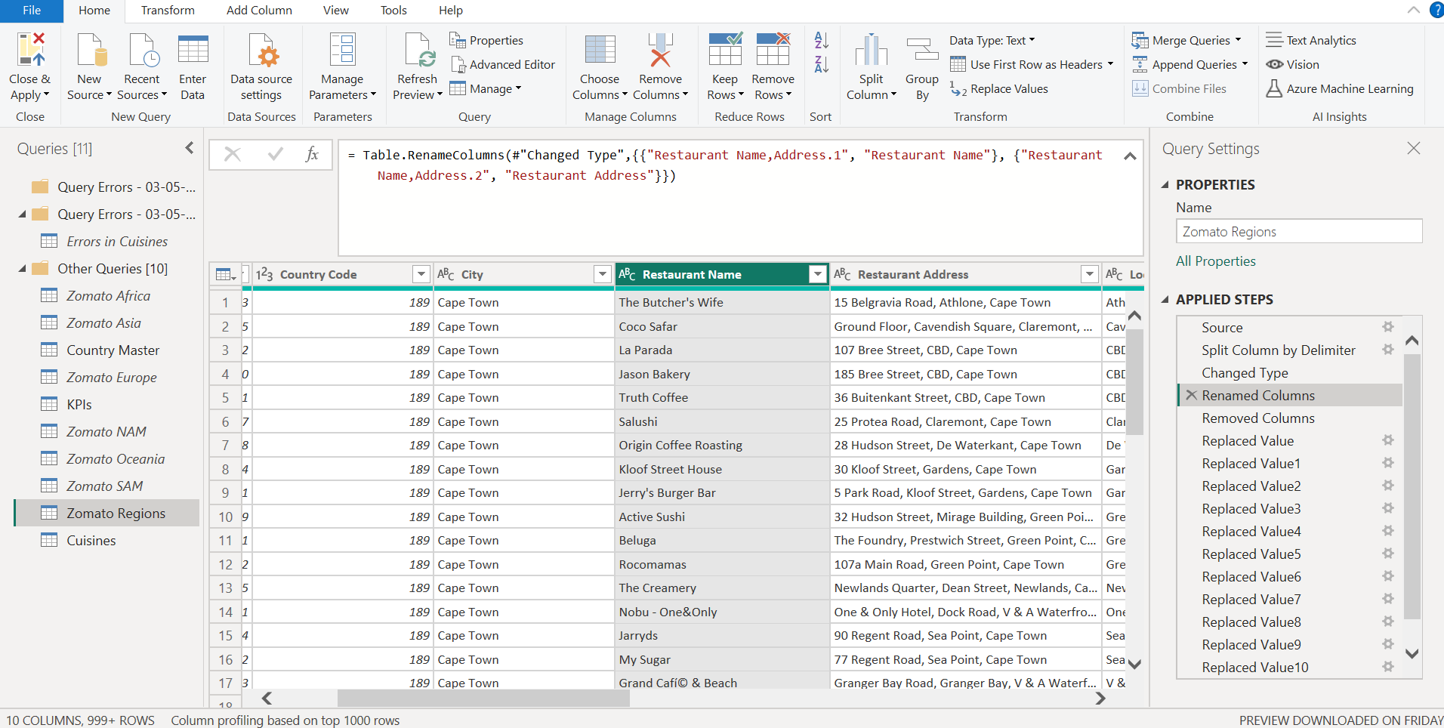

* Now we would remove the ‘Locality’ and ‘Locality Verbose’ column by clicking on ‘Remove Columns’.

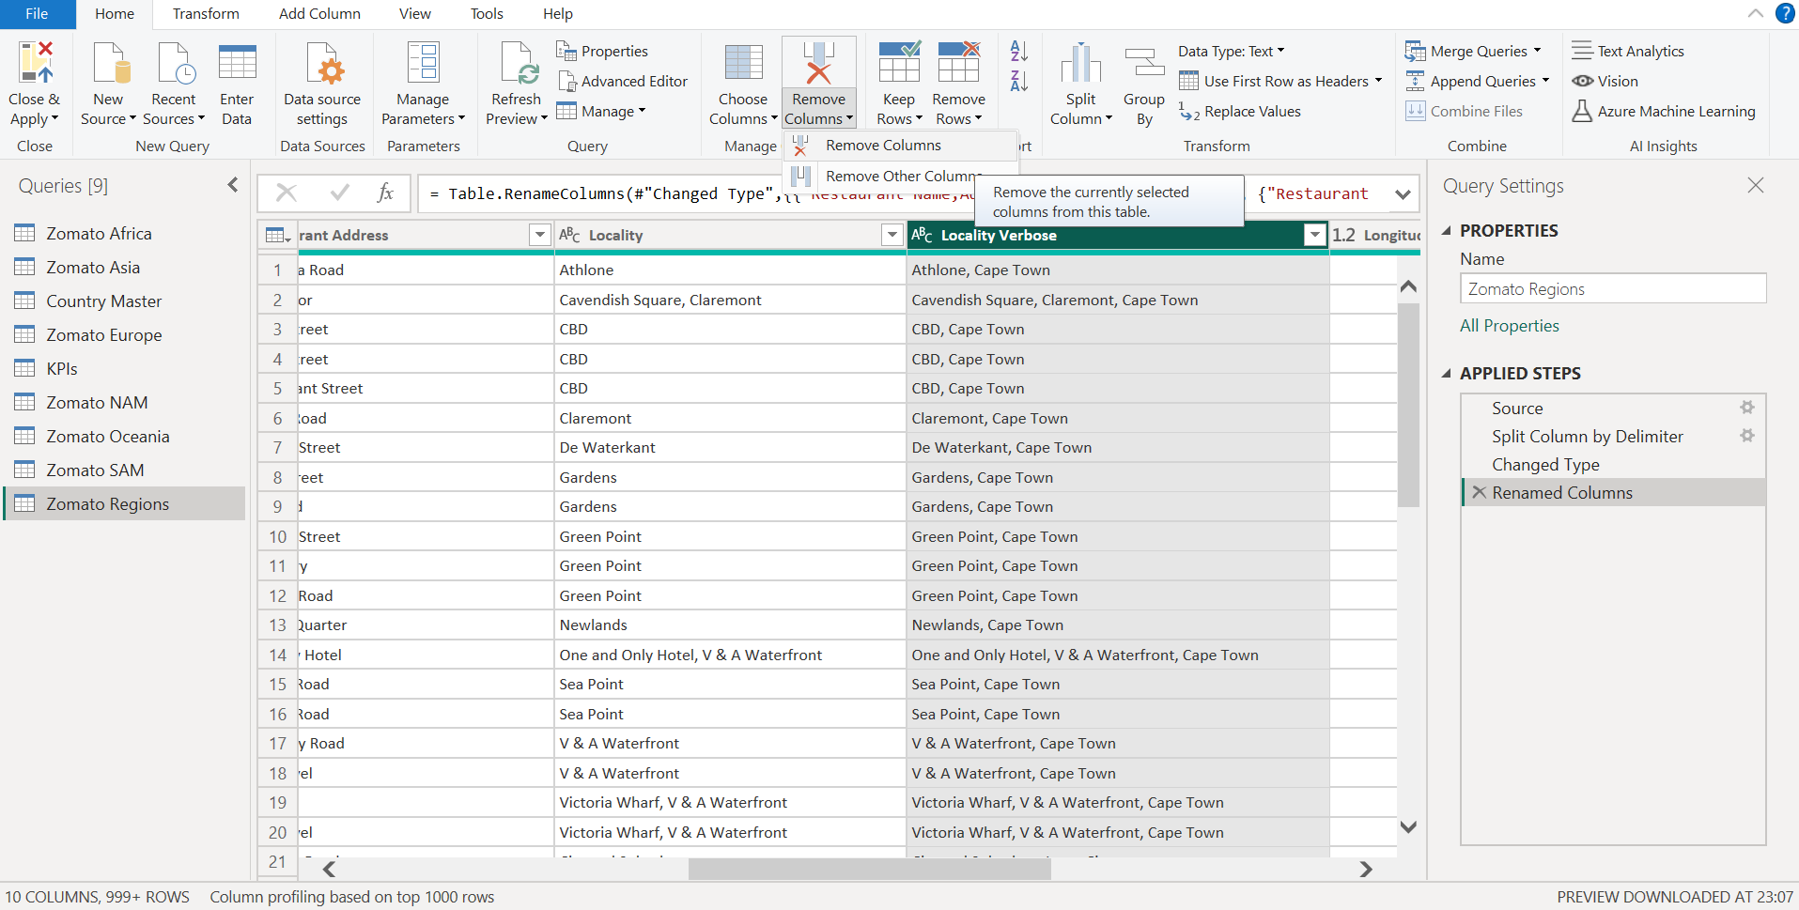

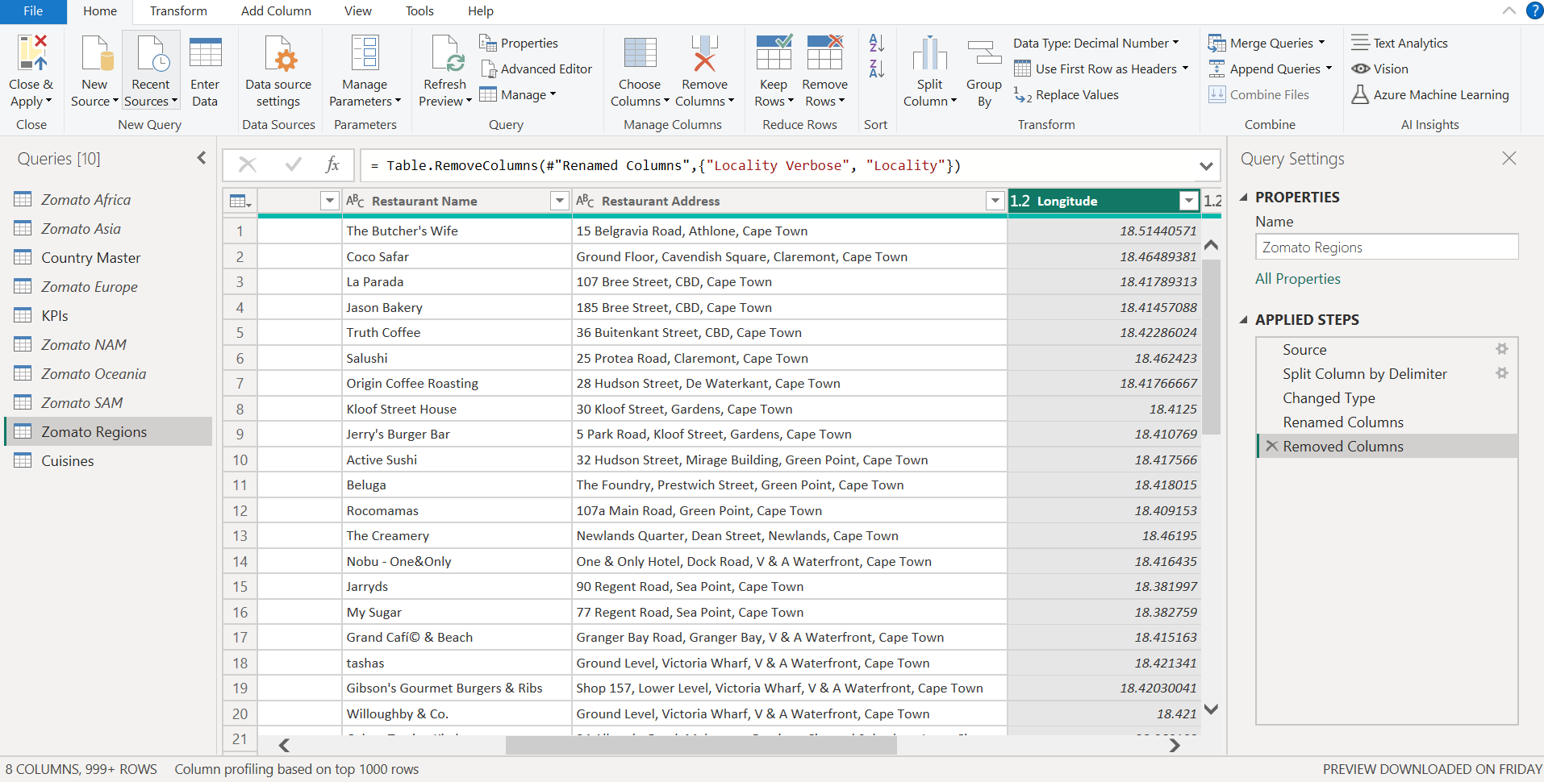

* In ‘City’ column replace the mentioned values "ÛÁstanbul" to "Istanbul"; "Cedar Rapids/Iowa City" to "Cedar Rapids" ; "Brasí_lia" to "Brasília"; "Sí£o Paulo" to "São Paulo"; "Makati City" to "Makati"; "Mandaluyong City" to "Mandaluyong"; "Pasay City" to "Pasay"; "Pasig City" to "Pasig"; "Quezon City" to "Quezon"; "San Juan City" to "San Juan"; "Tagaytay City" to "Tagaytay"; "Taguig City" to "Taguig".

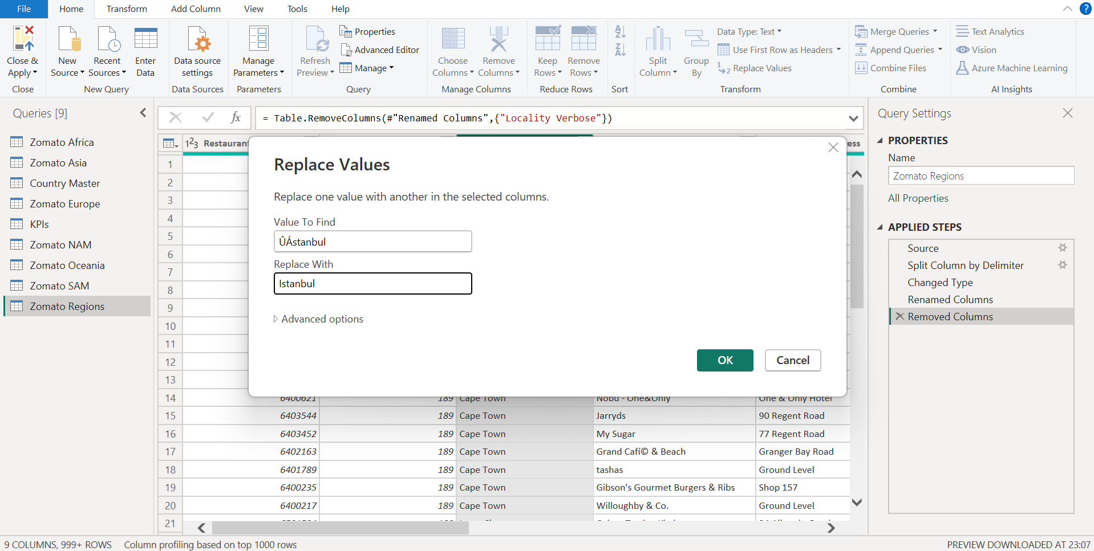

## 3.3 Table – Cuisine

We would create a new Table ‘Cuisines’ which would give us details about restaurant and their cuisines.

* Duplicate the ‘Zomato Regions’ and rename the new table to ‘Cuisines’.

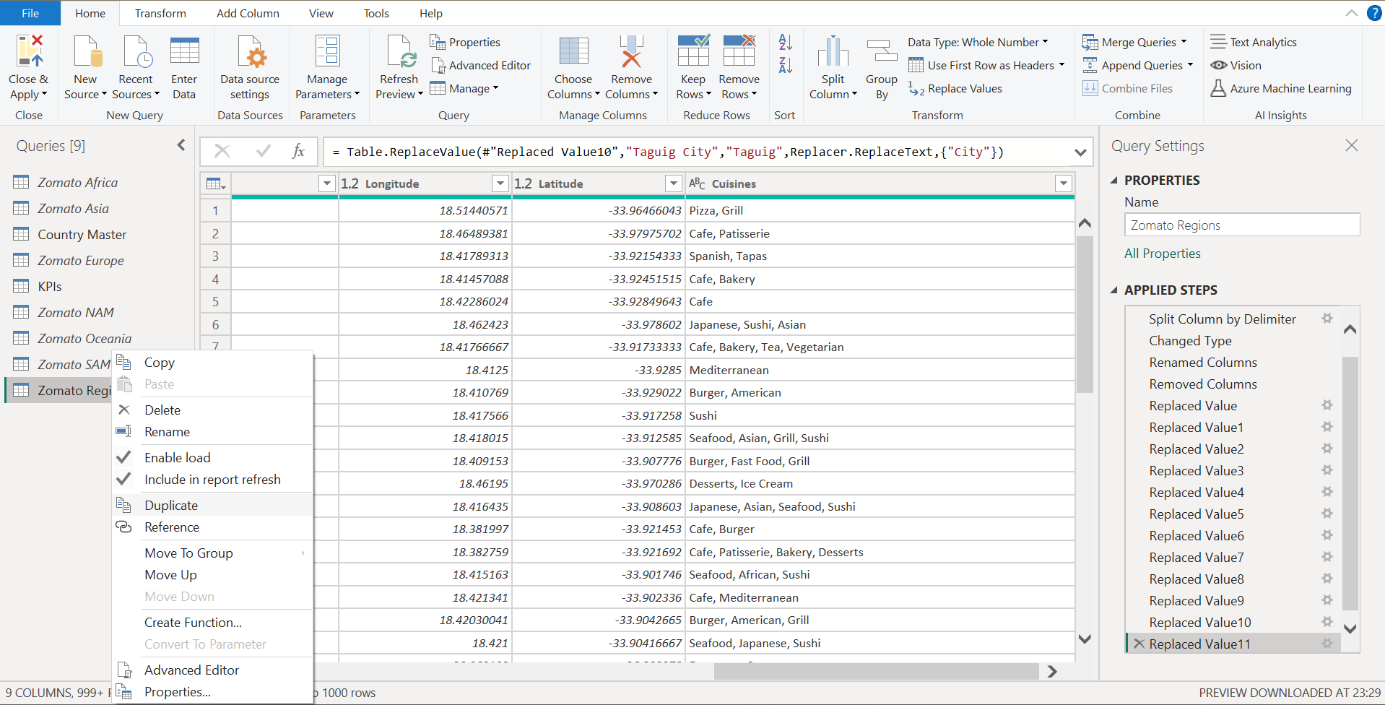

* Navigate to ‘Choose Columns’ under Home Tab and select the Tables we wish to keep(Restaurant ID and Cuisines).

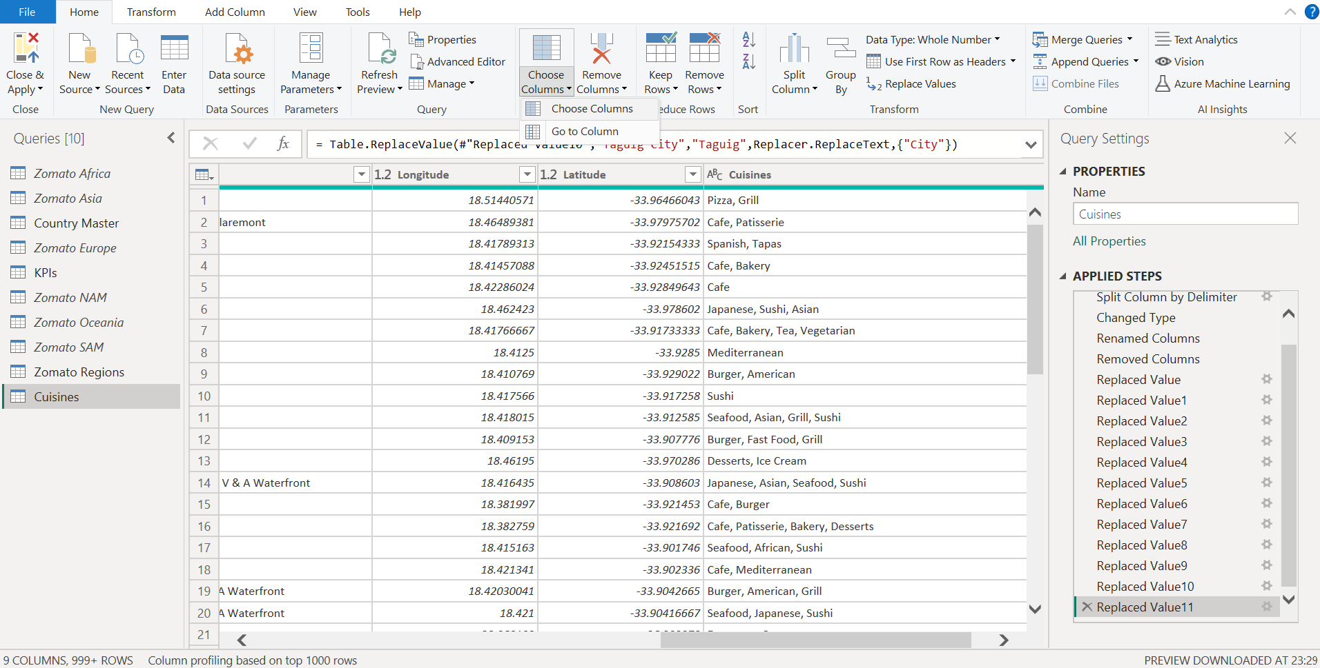

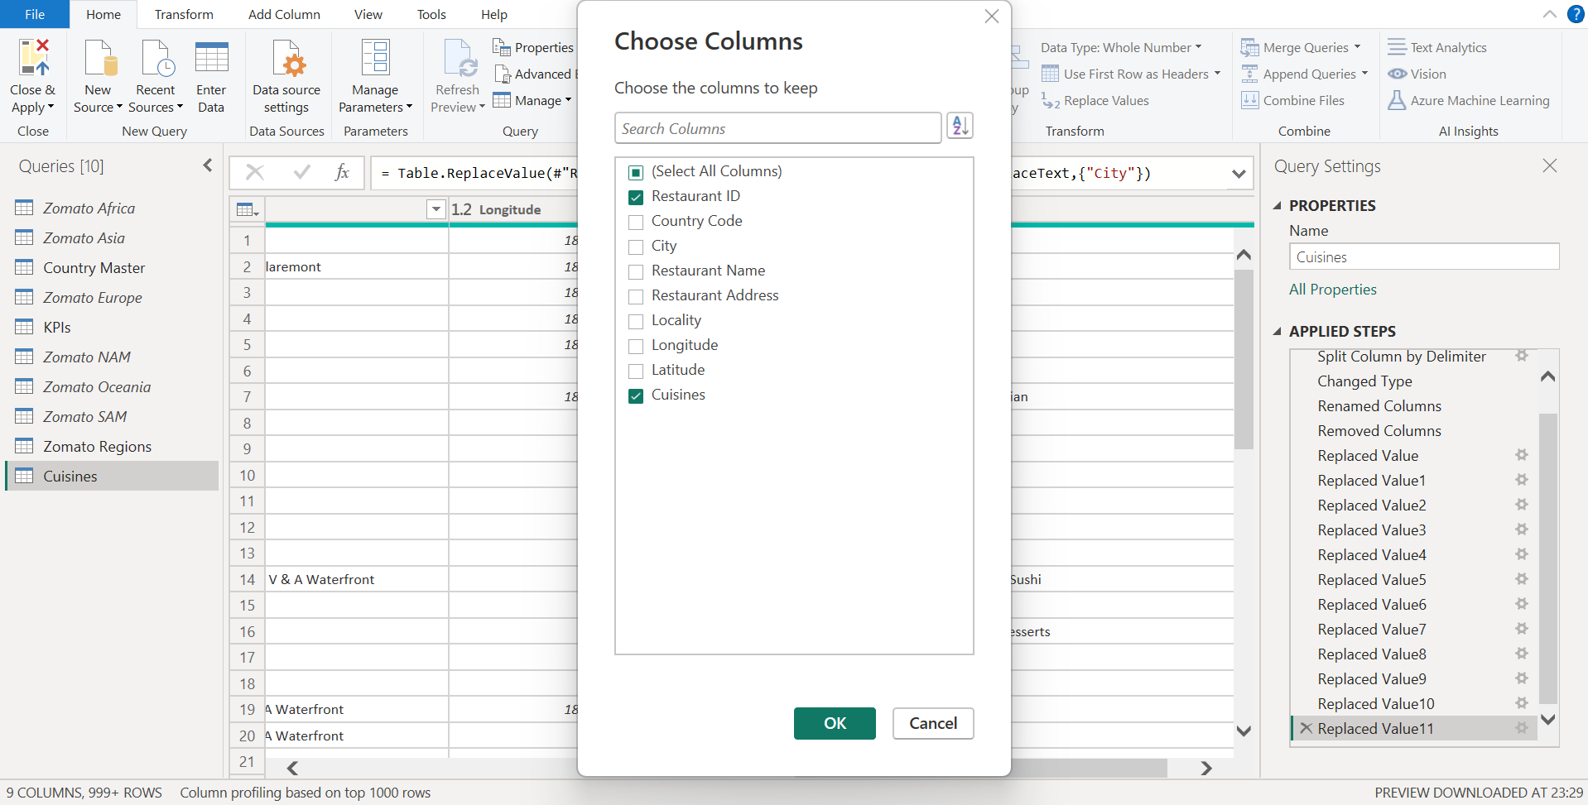

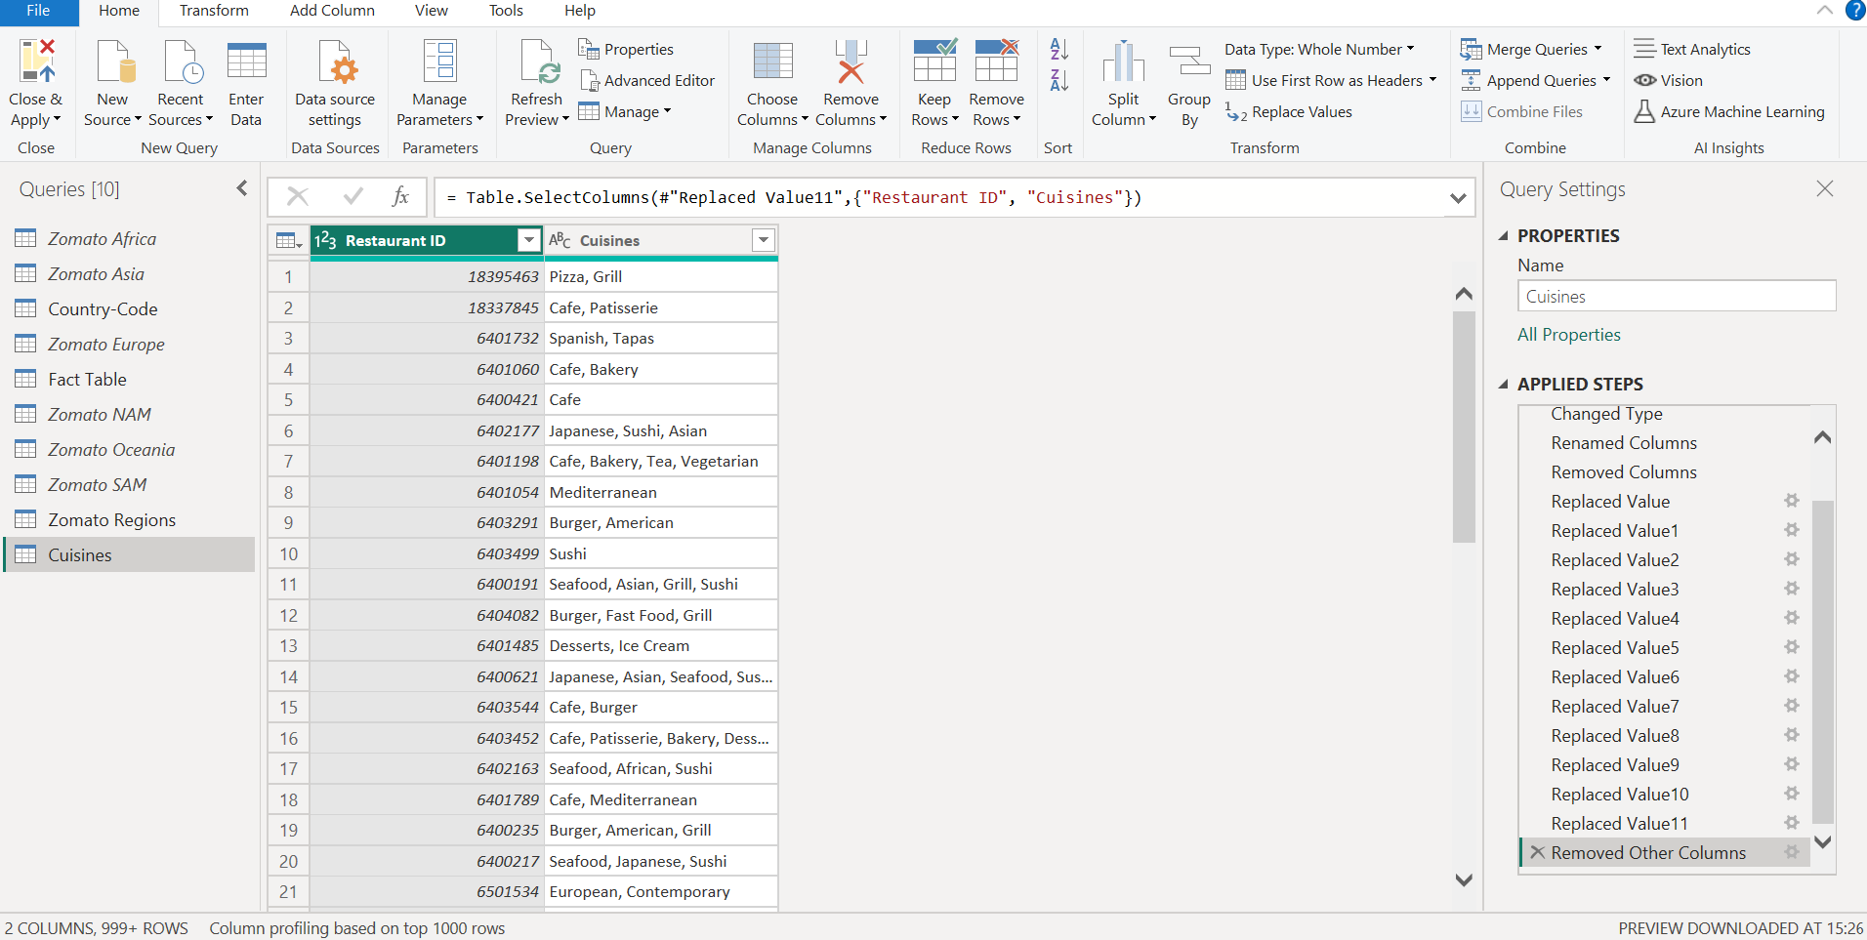

* Now, we need to split the ‘Cuisines’ column by Delimiter (‘,’)

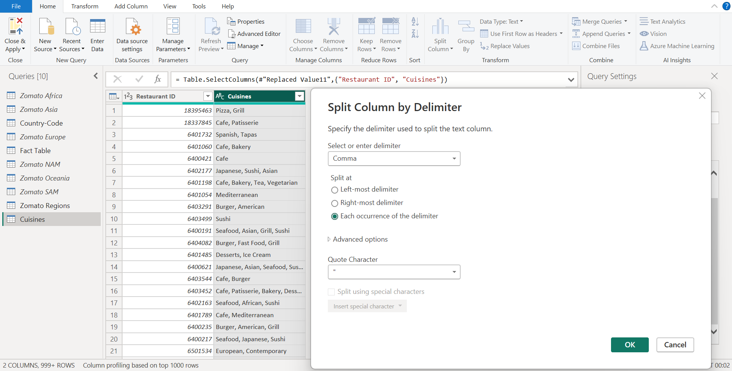

* Upon Split, we would get data in ‘Wide Format’, to convert it into proper format i.e. ‘Long Format’ we would use ‘Unpivot Columns’ function.

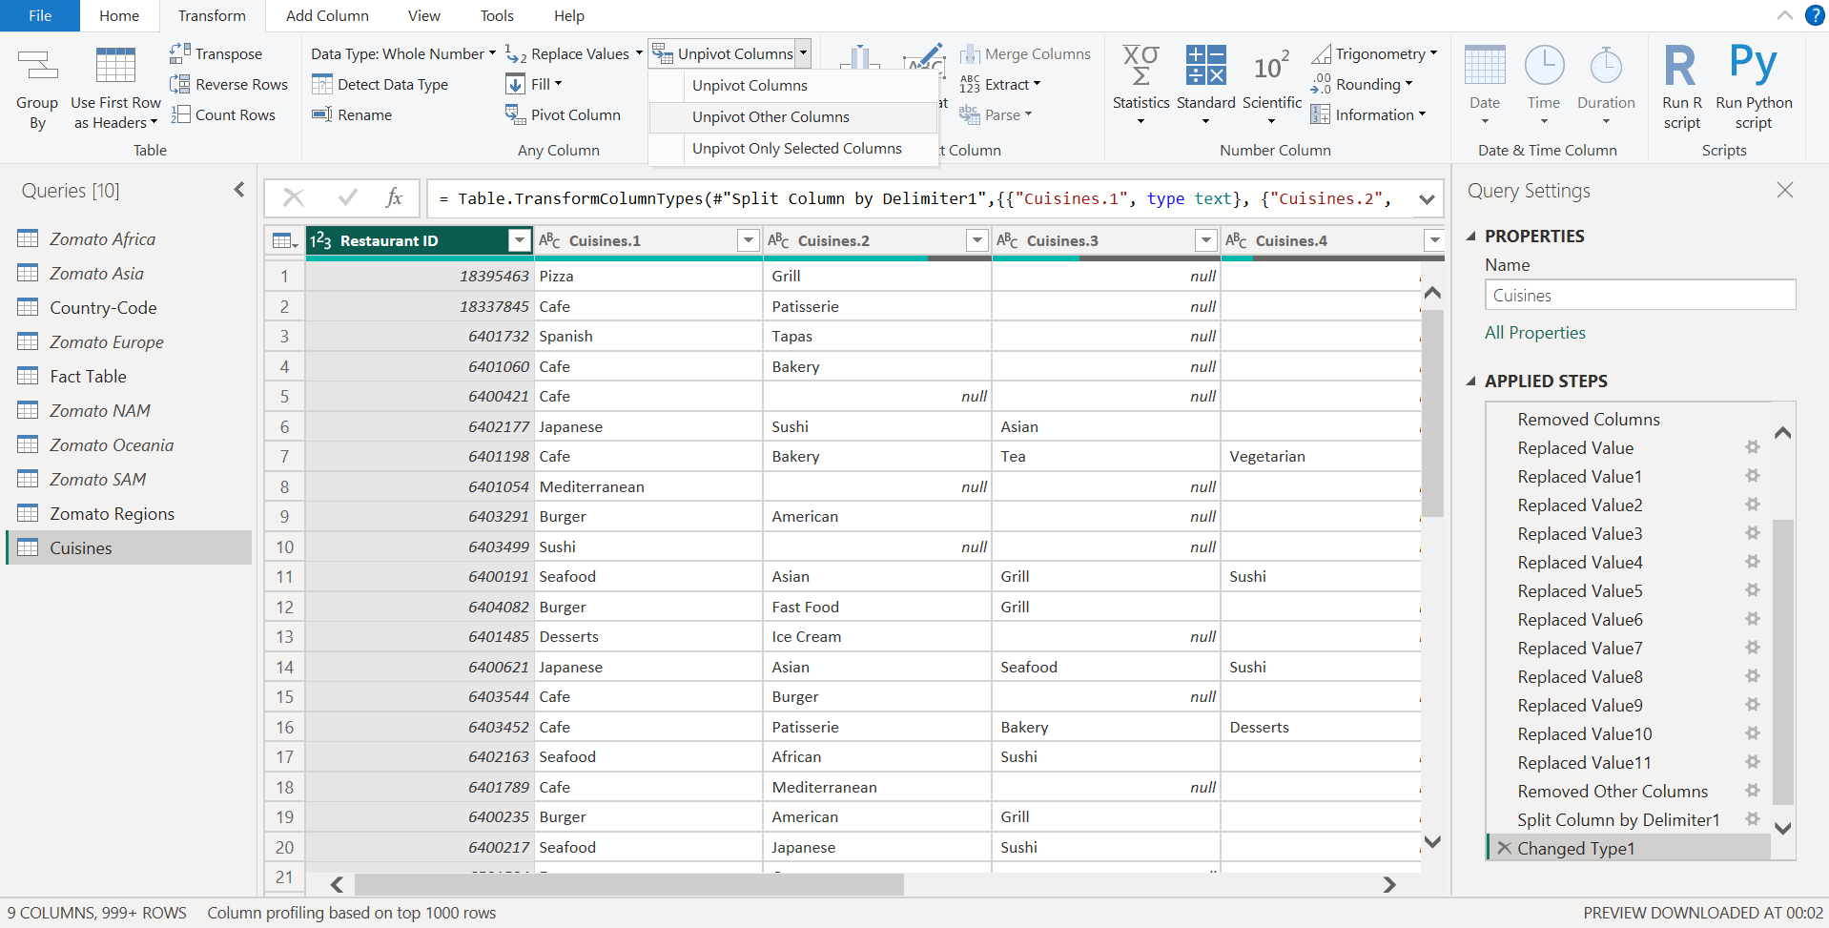

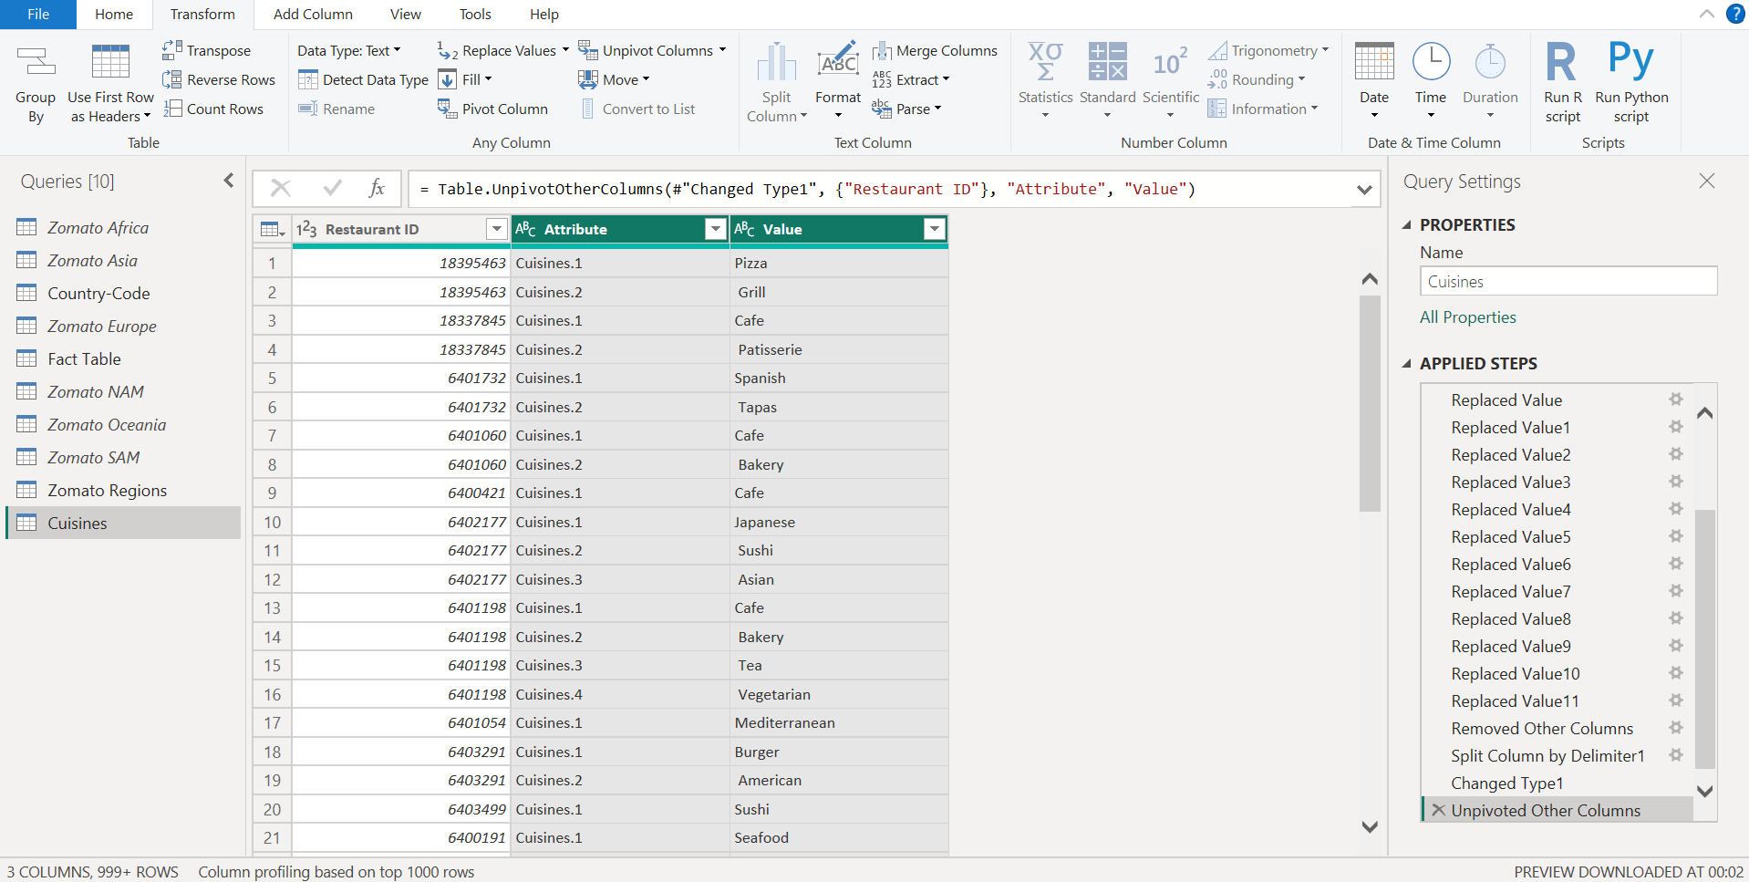

* Remove the ‘Attribute’ Column, Rename ‘Value’ to ‘Cuisines’. We would Trim the Cuisines column to get the data in proper format (without spaces)

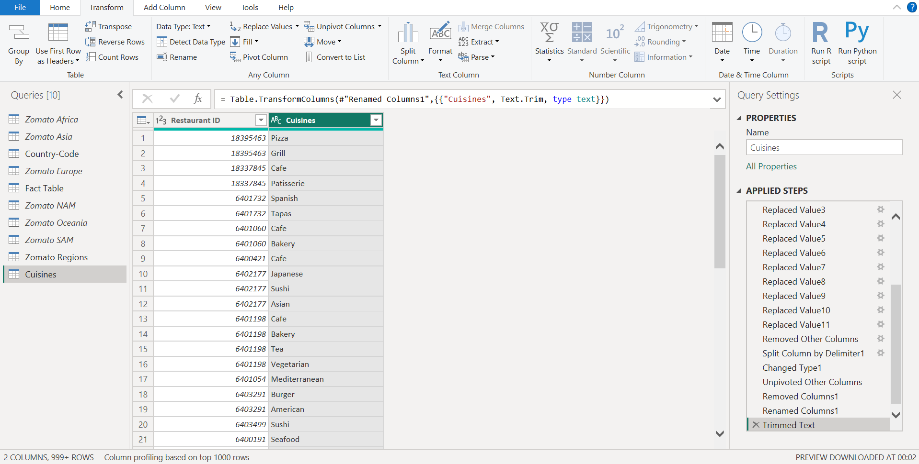

## 3.4 Table – Country -Code

We would rename the ‘Country Master’ table to ‘Country-Code’ and clean the data in it.

* Remove the rows with ‘null’ value using ‘Remove Blank Rows’ option under ‘Home Tab’ > ‘Remove Rows’

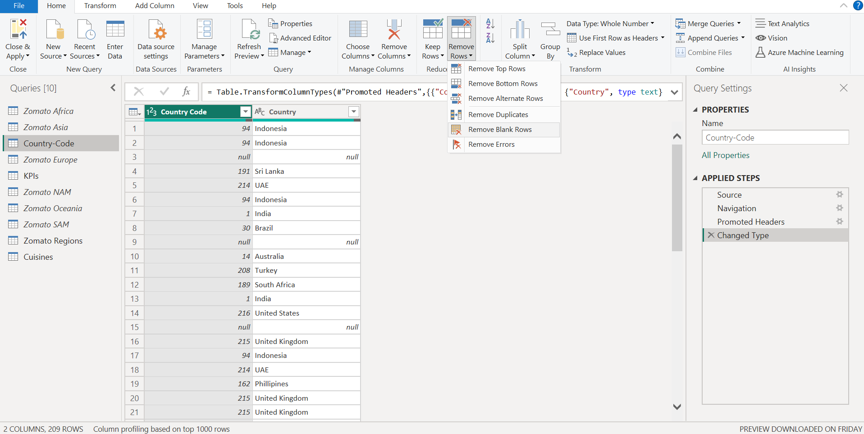

* Once all the ‘null’ rows are remove, we would remove the duplicate values to get a unique list of country code and country. This would be done using ‘Remove Duplicate’ option under the ‘Home Tab’ > ‘Remove Rows’

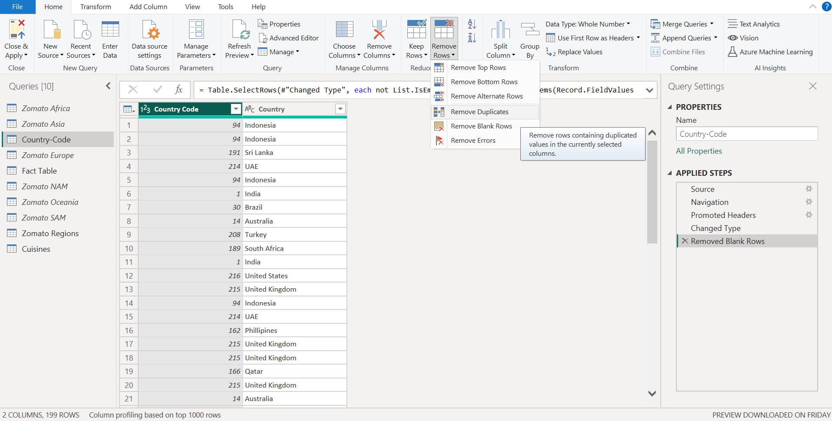

* As country-code is a dimension table it must only include unique and non-blank values.

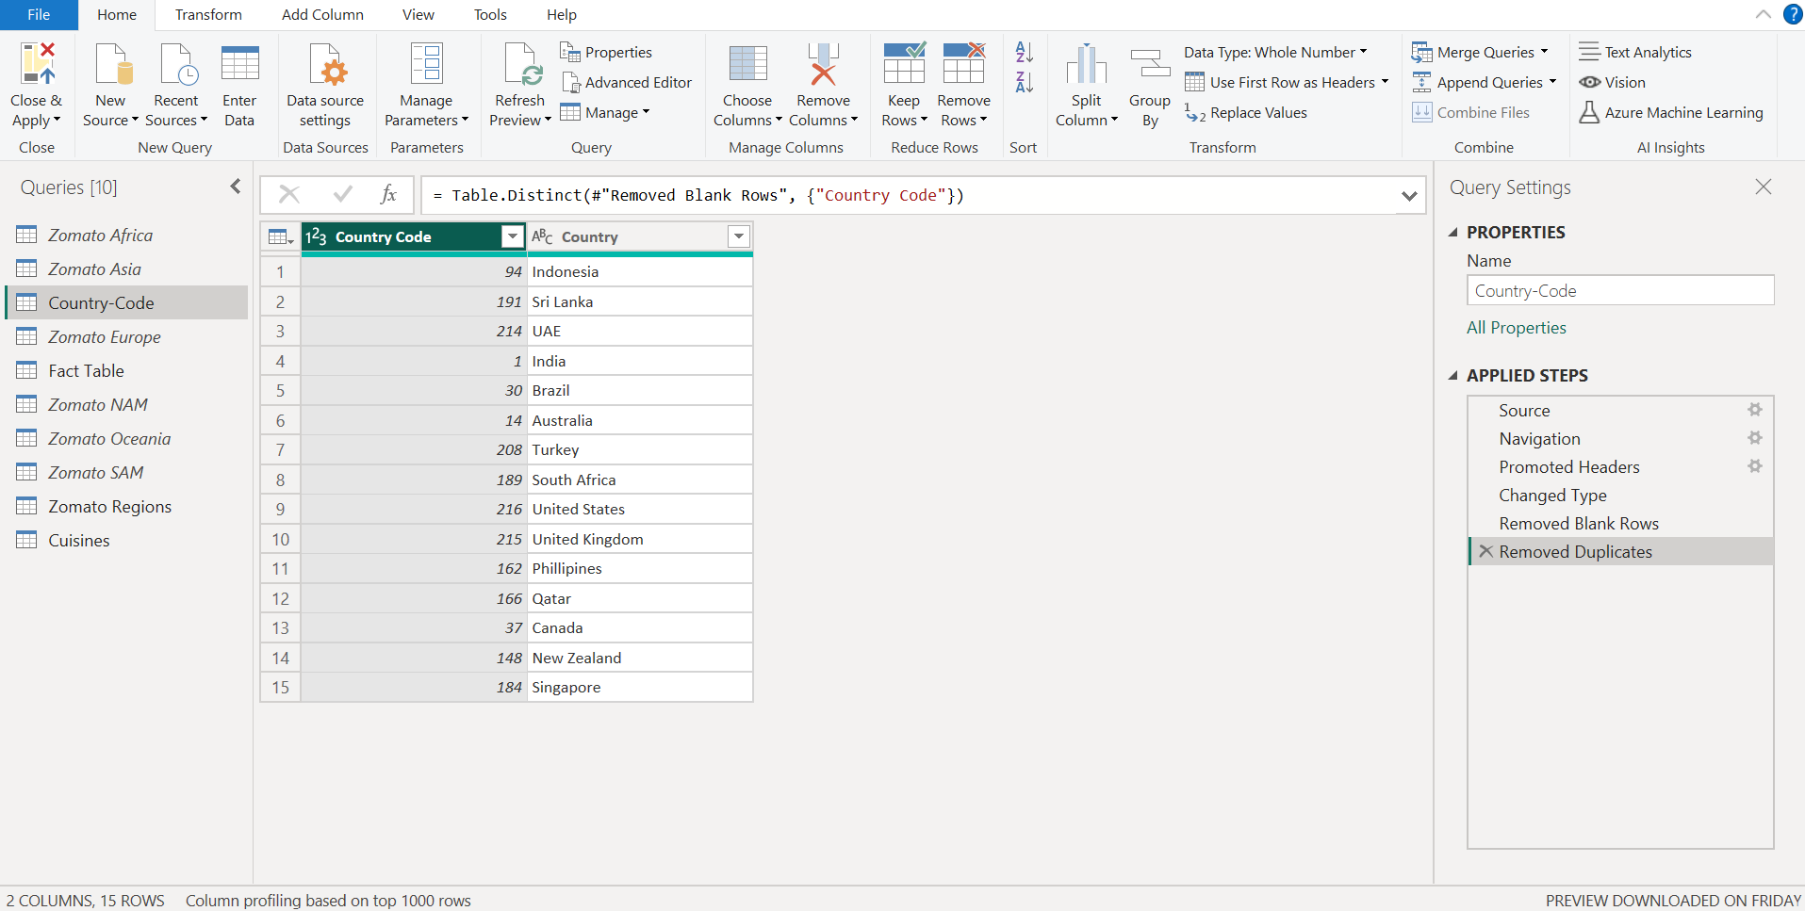

## Table – KPIs

We would rename the KPIs table to ‘Fact Table’

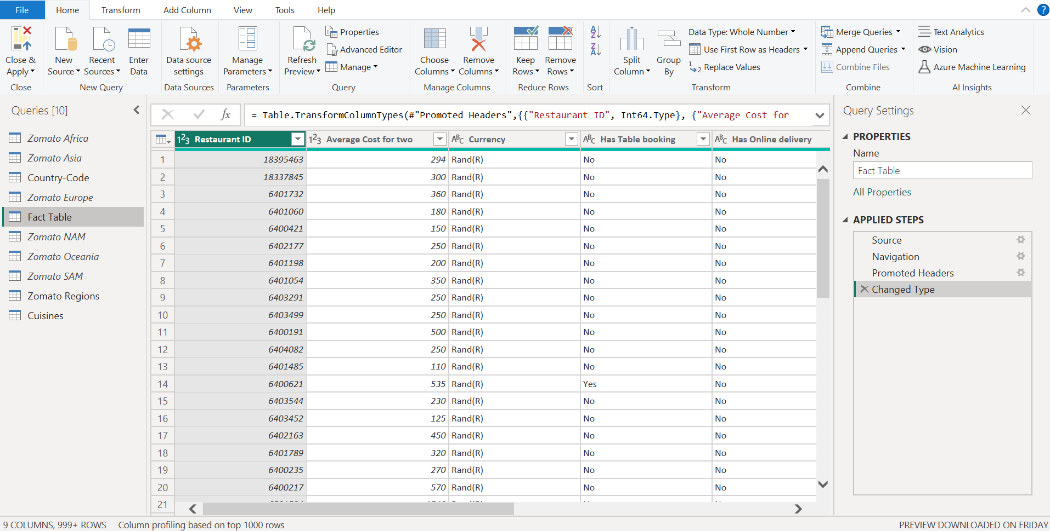

# Data Modelling

In the data model view we can see how the tables are connected to each other.

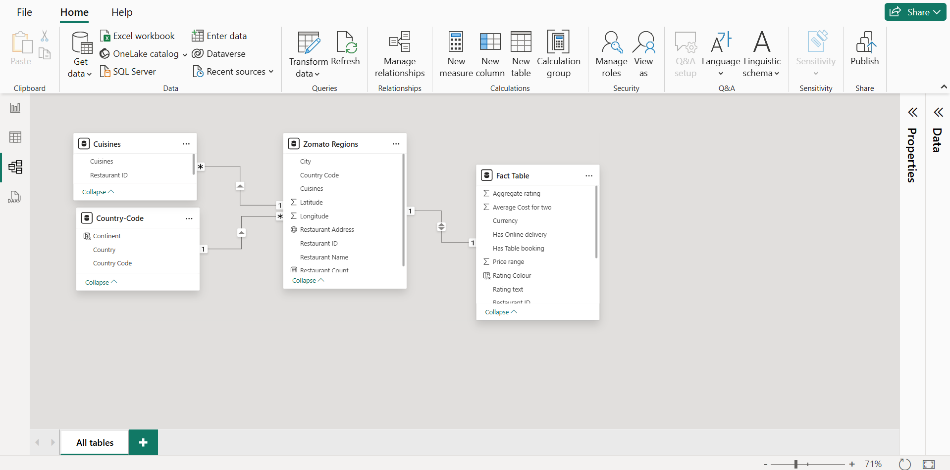

Note: If a relation does not automatically exists navigate to ‘Manage Relationship’> ‘Auto Detect’.

# Data Analysis Expression (DAX)

## 4.1 Calculated Columns

Rating Color Column:

To display different colours as per the average rating follow the below mentioned steps:

* Navigate to the Table View and select the ‘Fact Table table, we would be creating a calculated column by clicking on ‘New Column’

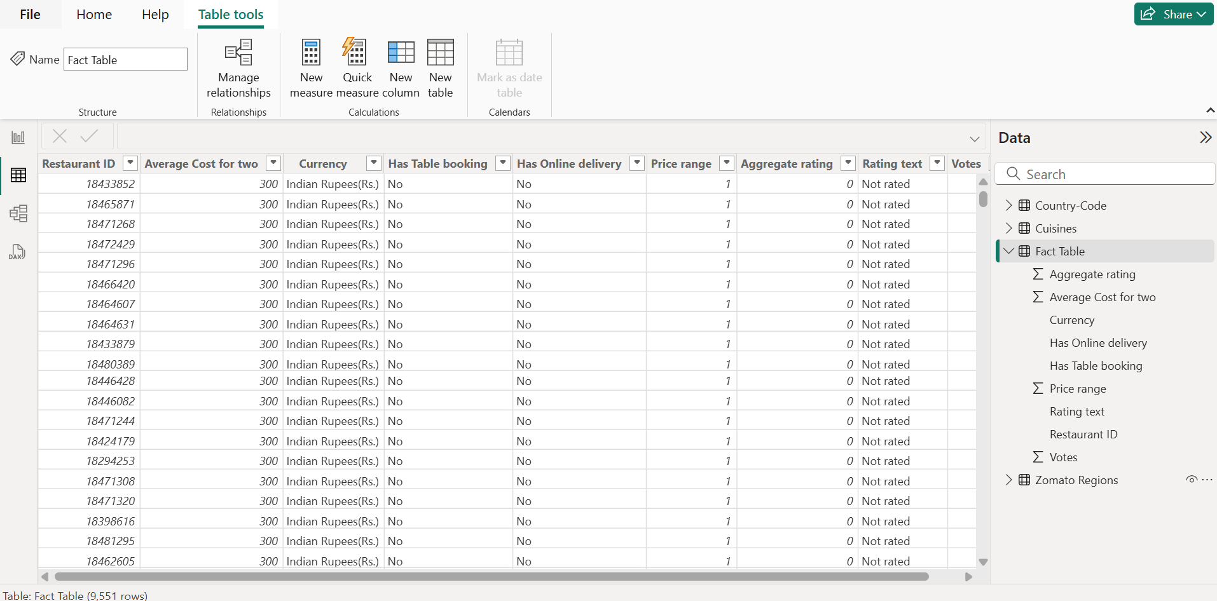

* Write the DAX Formula as follows:

Rating Colour = SWITCH(TRUE(),'Fact Table'[Aggregate rating]>=4.5,"Dark Green", 'Fact Table'[Aggregate rating]>4, "Green", 'Fact Table'[Aggregate rating]>=3.5, "Yellow", 'Fact Table'[Aggregate rating]>=2.5, "Orange", 'Fact Table'[Aggregate rating]>=1.8, "Red", 'Fact Table'[Aggregate rating]<=1.7, "Blue")

Note : Switch function used to avoid nested if

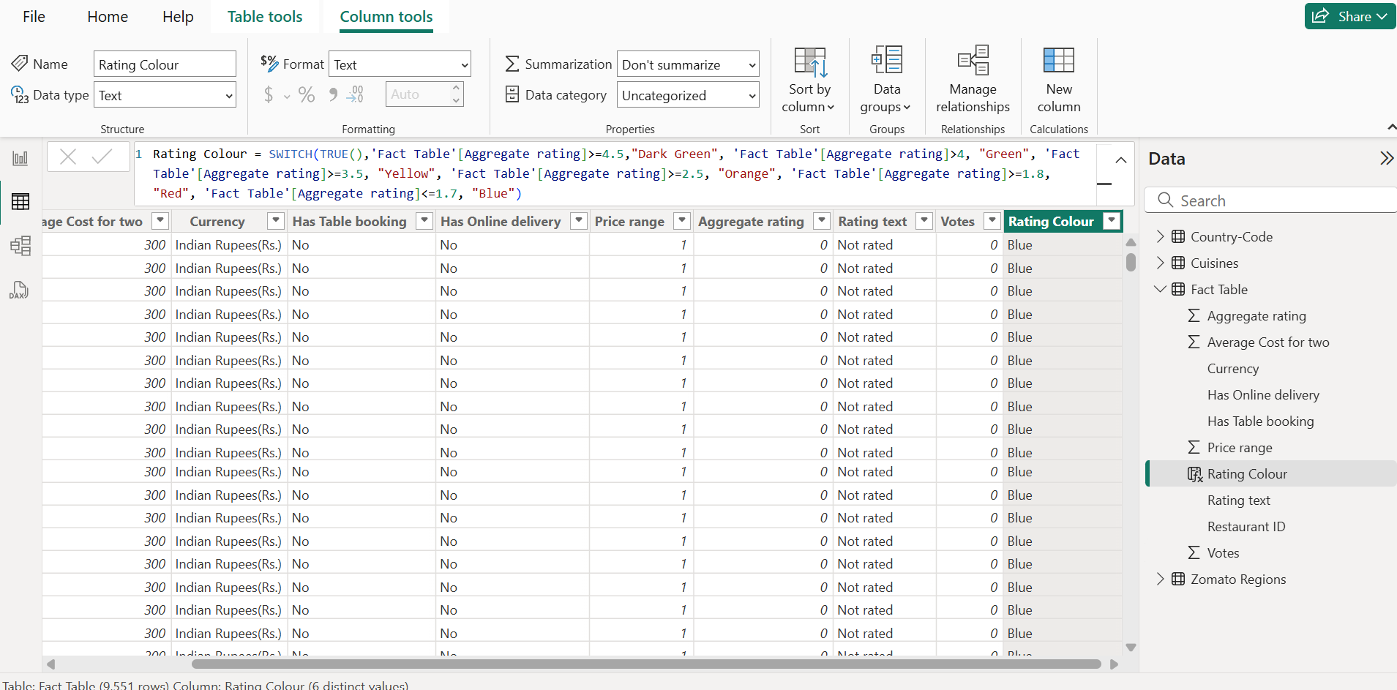

## 4.2 Calculated Measures

To get the number of restaurants , average cost, average rating and cuisine count we would add a new measure in ‘Zomato Regions’, ‘Fact Table’ and ‘Cuisines’ table respectively.

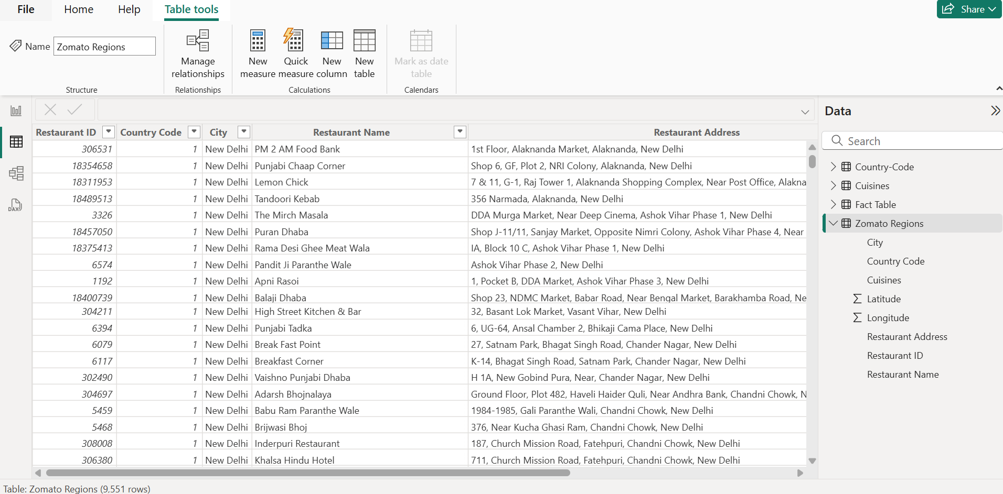

* Restaurant Counts:

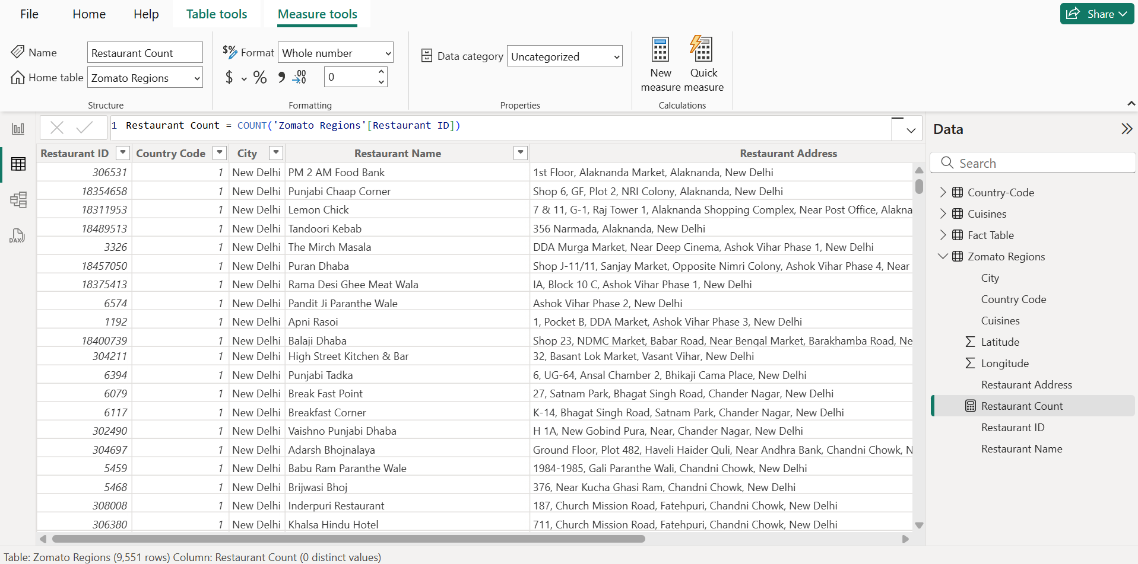

* Average Cost

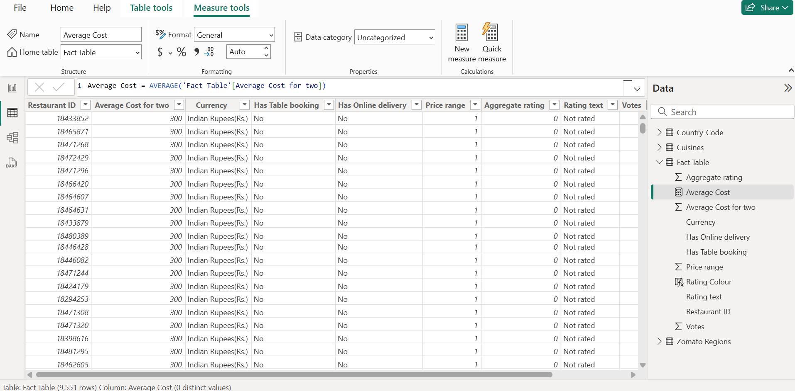

* Average Rating

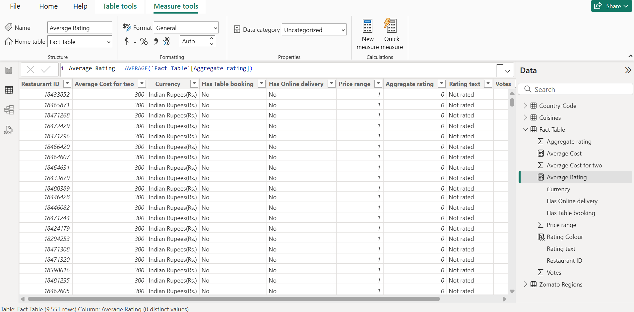

* Cuisine Count

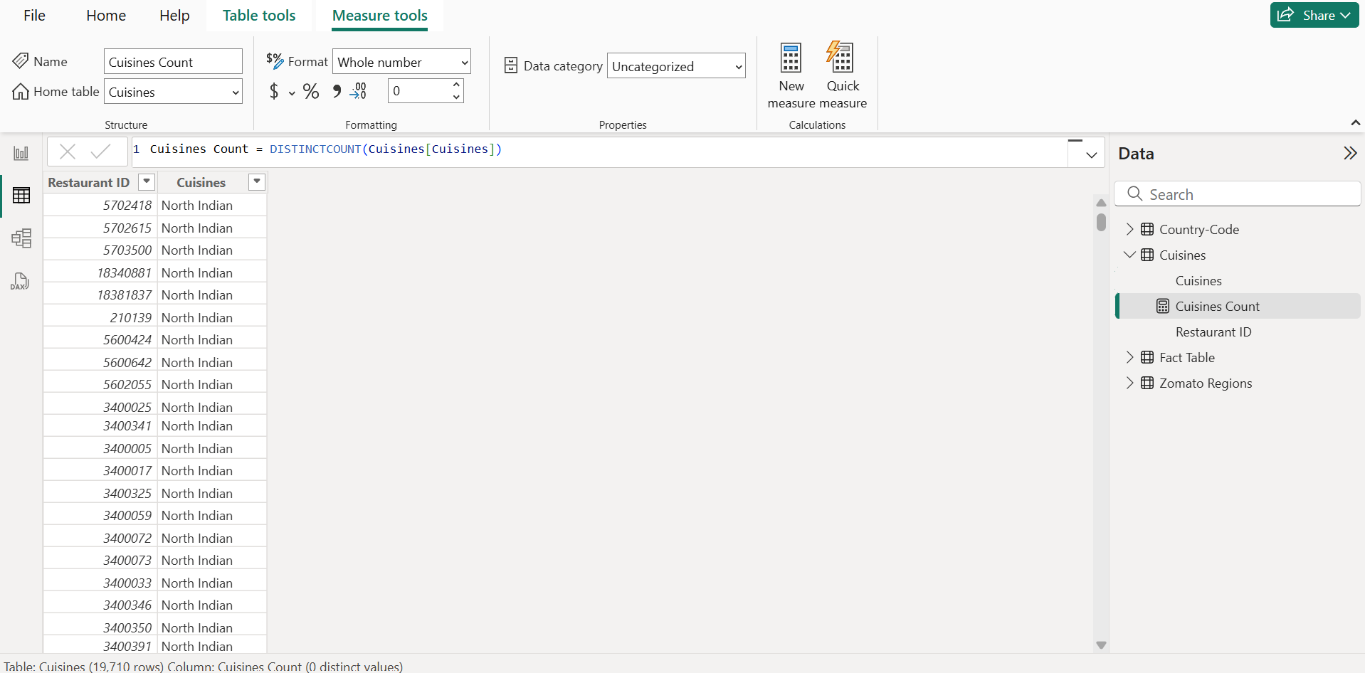

## 4.3 Continent Column

Navigate to the ‘Country-Code’ table under Table View and click on ‘New Column’ and mention the below query to get country and continent mapping

Continent = SWITCH( TRUE(),

    'Country-Code'[Country] IN {"India", "Sri Lanka", "UAE", "Indonesia", "Philippines", "Qatar", "Singapore", "Turkey"}, "Asia",

    'Country-Code'[Country] IN {"United States", "Canada"}, "North America",

    'Country-Code'[Country] = "Brazil", "South America",

    'Country-Code'[Country] IN {"Australia", "New Zealand"}, "Australia",

    'Country-Code'[Country] = "United Kingdom", "Europe",

    'Country-Code'[Country] = "South Africa", "Africa",

    "Other"

)

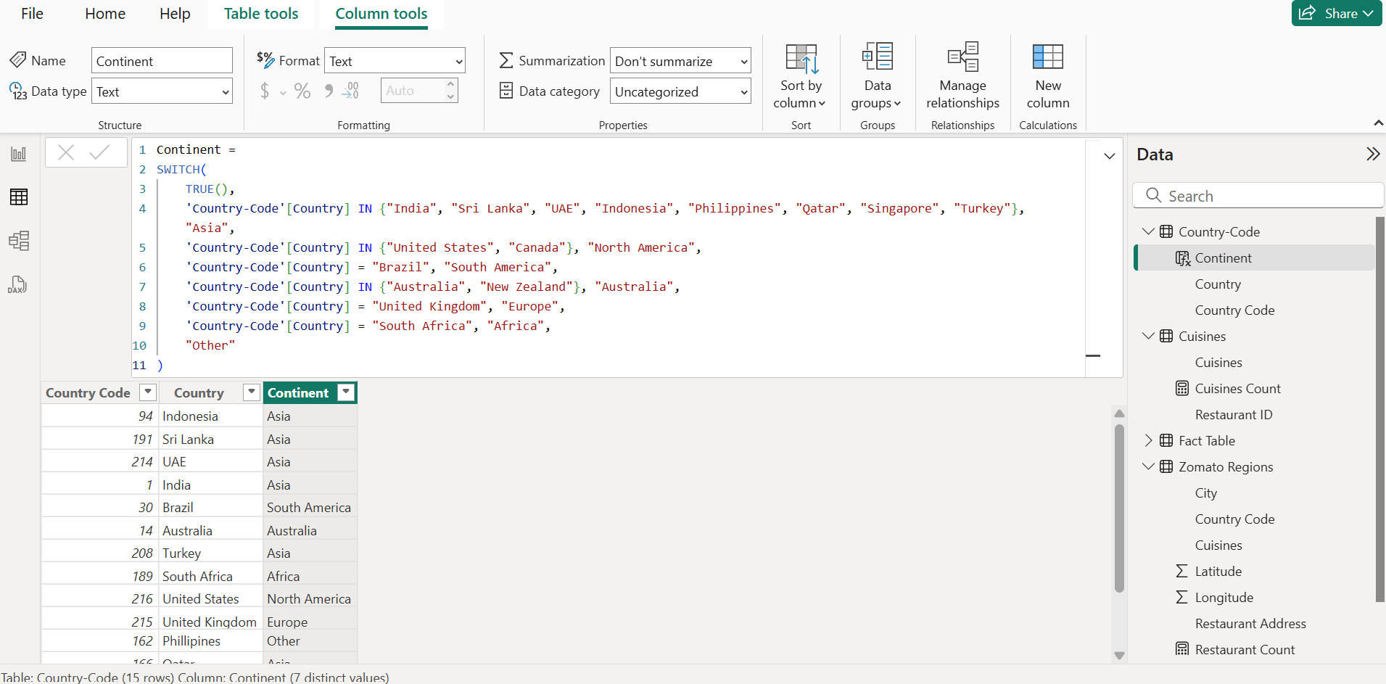

# Data Visualization and Reporting

* Derive data on the total number of restaurants worldwide, including continents, countries, and cities.

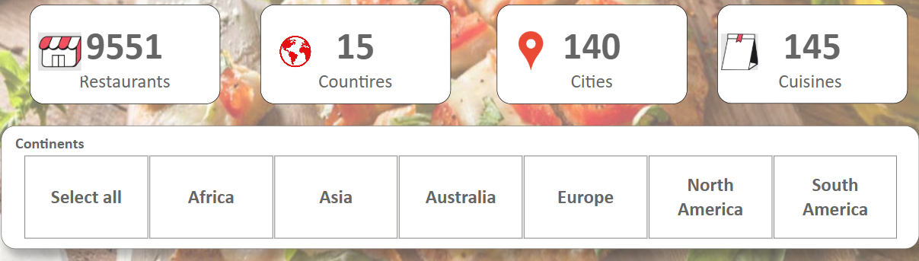

* View data on a global scale with the capacity to drill down to a granular level.

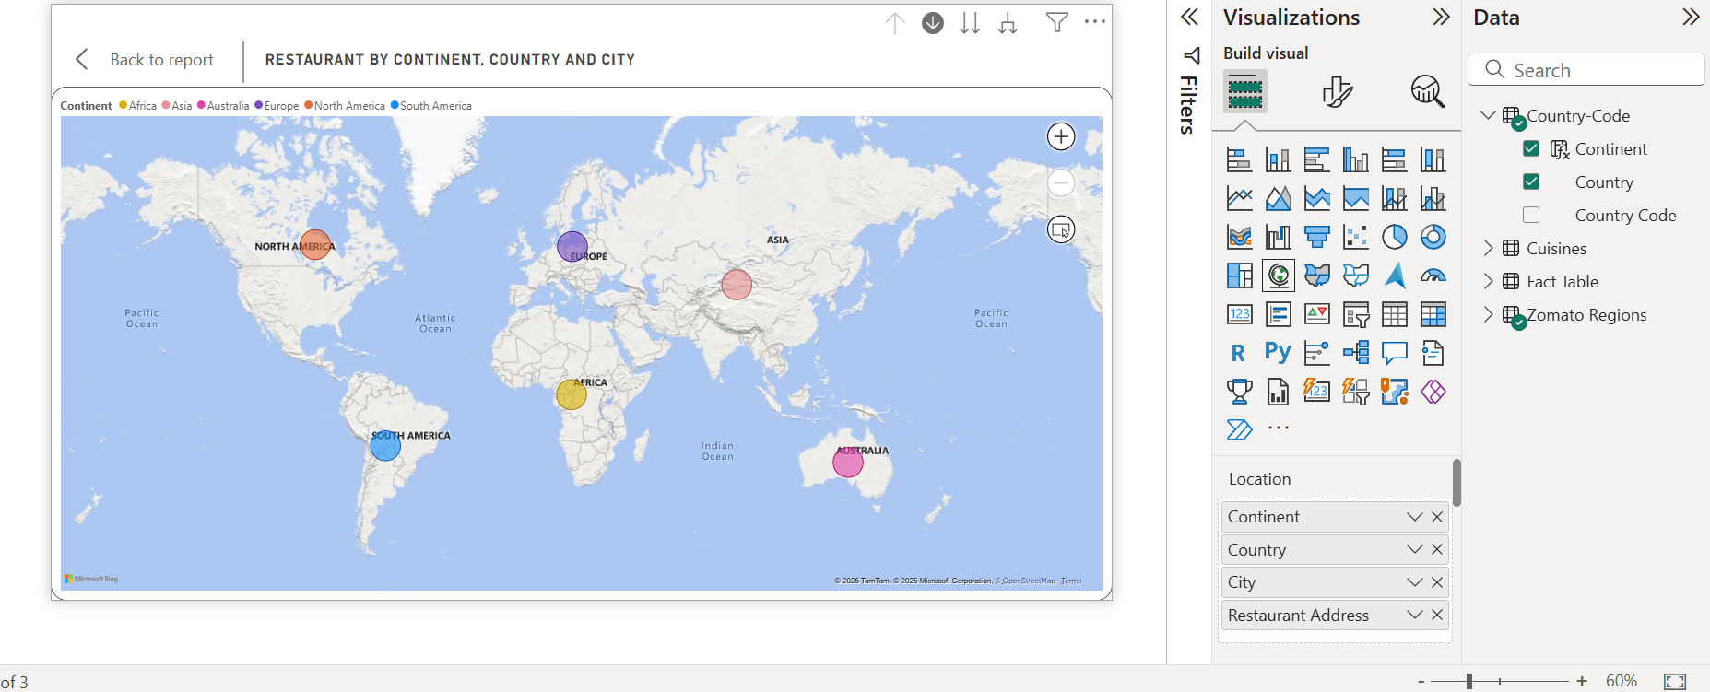

* Derive data on the restaurants with the highest average customer ratings.

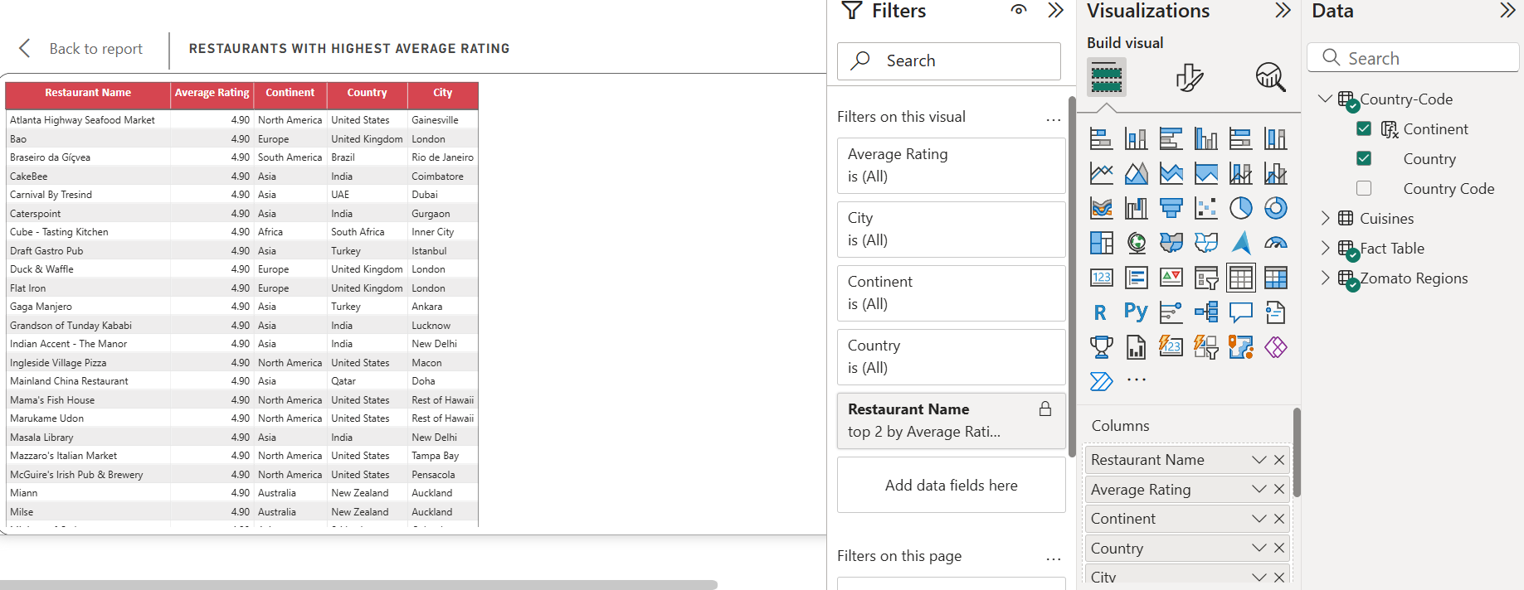

* Discover the restaurants with the lowest average costs.

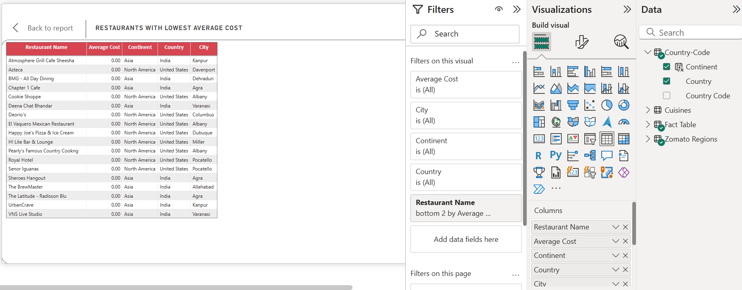

* Filter and view information on the restaurants based on:
  + Their geographical dimensions such as continent, country, and city.
  + The service they provide, such as online ordering or reservation services.

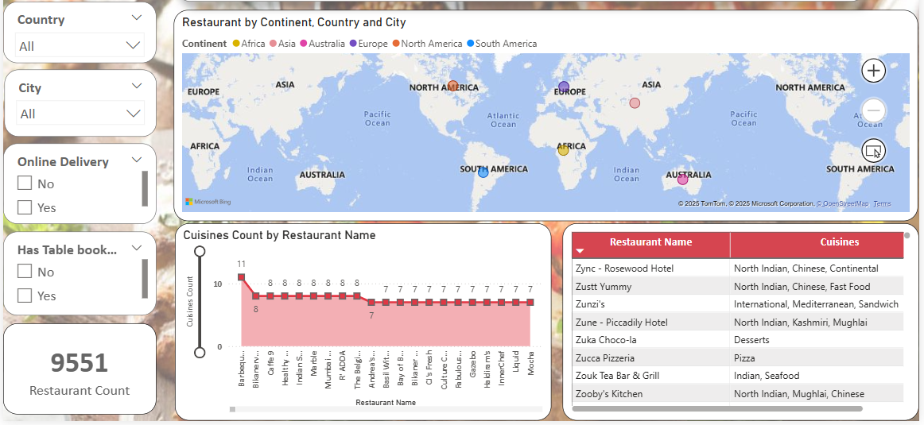

* + The average rating slab by color.

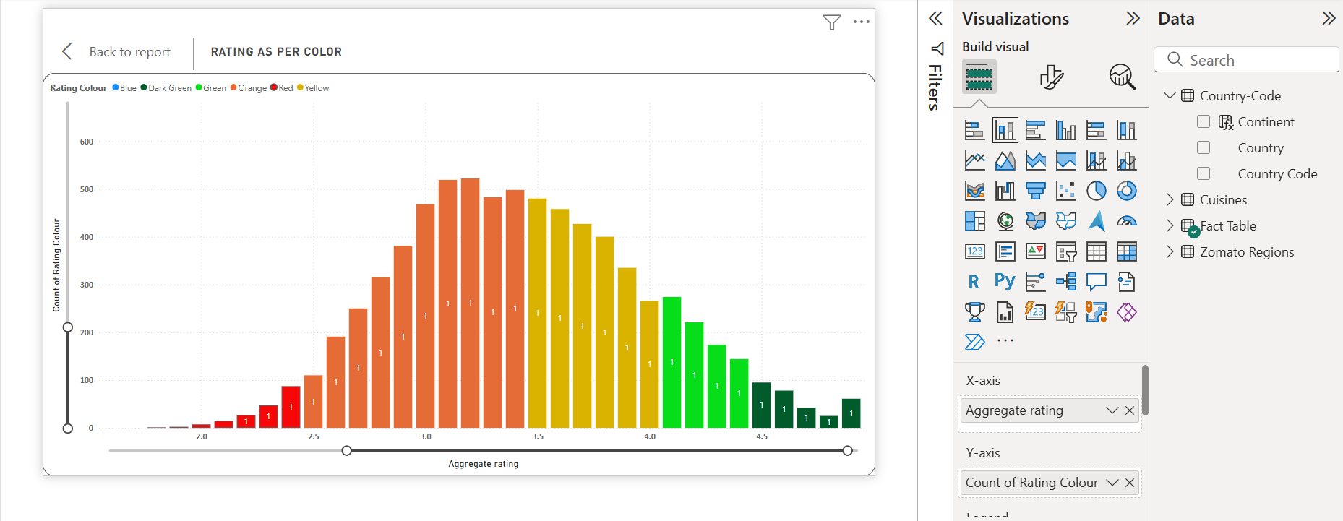

* Identify the restaurants with the most cuisines served.

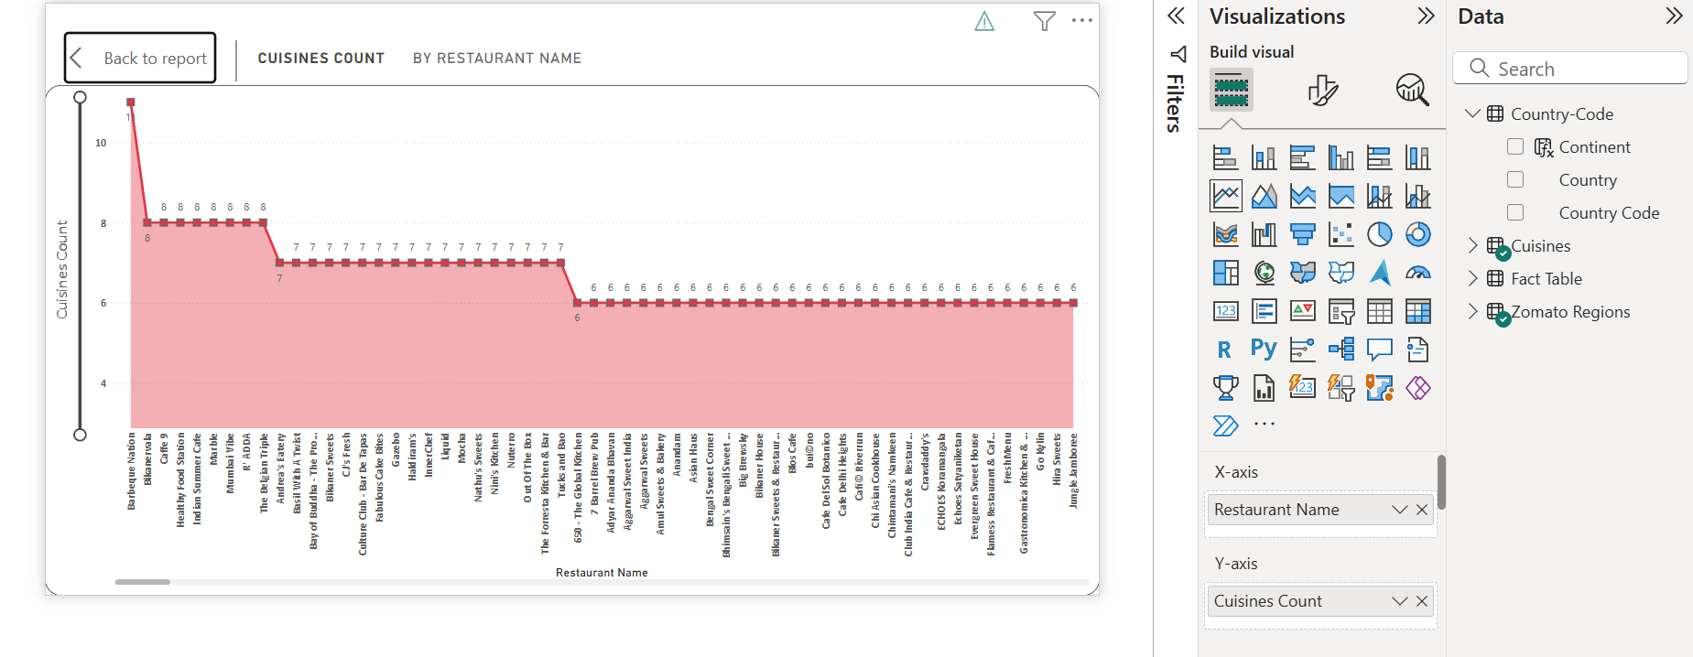

* Design a multi-page report that suits Zomato's theme with easy navigation across sections.
  + Page 1

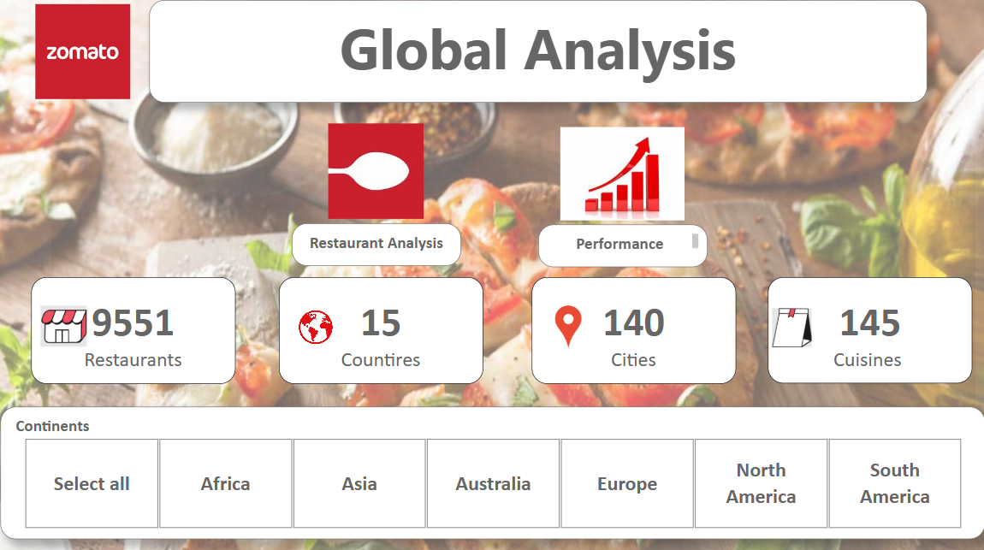

* + Page 2

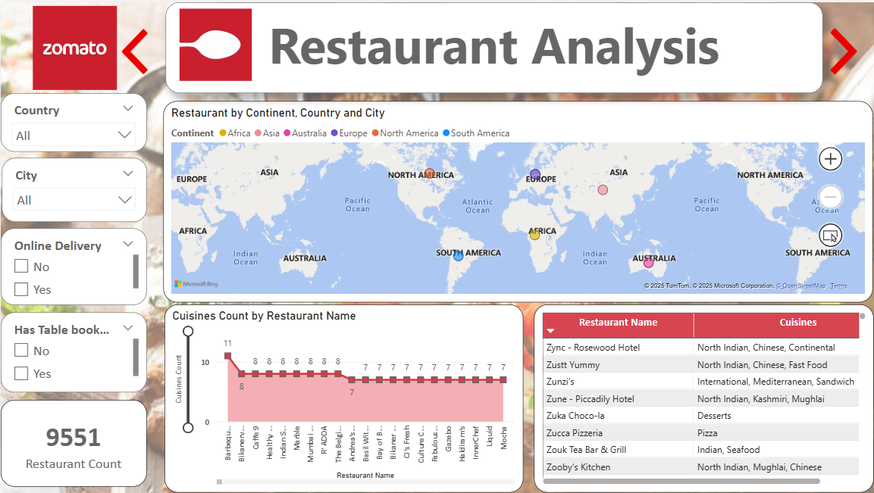

* + Page 3

